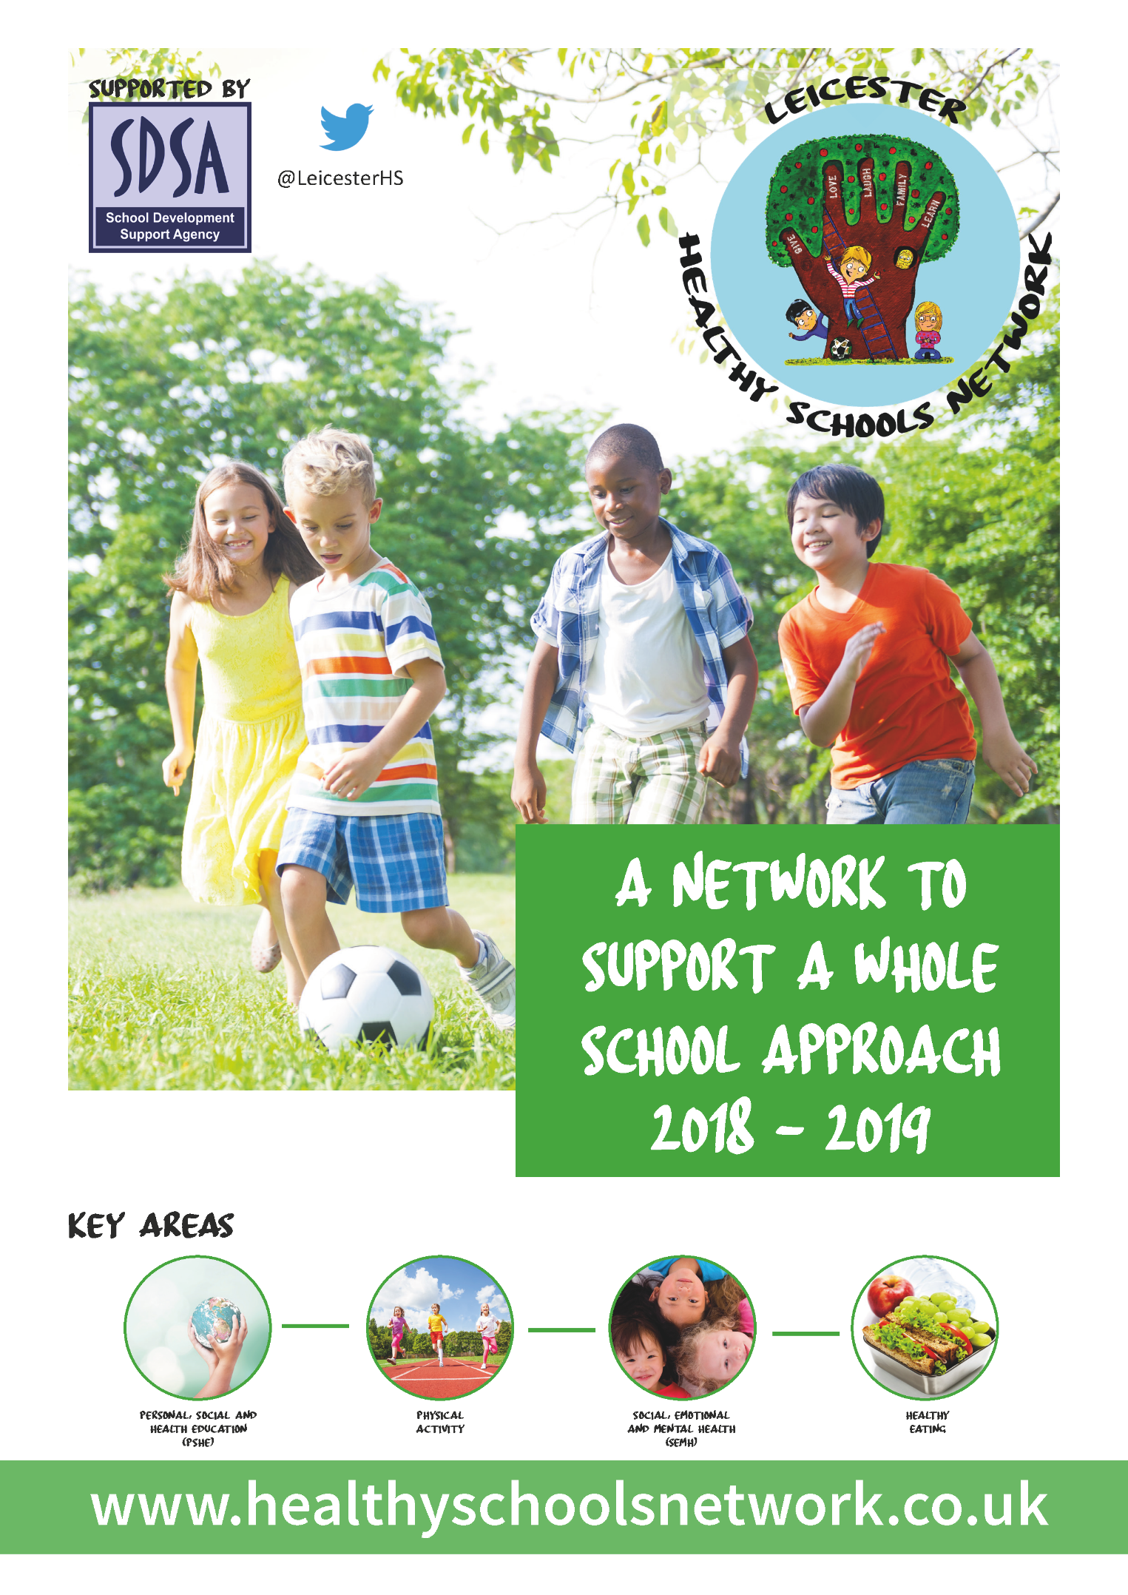
Workbook
Welcome

The Healthy Schools Network was set up as a response to demand expressed in the April 2016 survey of Leicester City schools and is supported by the School Development Support Agency (SDSA)*. The Network is a programme aimed to meet the health and wellbeing needs of children and young people, helping to raise attainment levels within schools and aims to bring together and showcase the provision available for schools by building relationships from around the East Midlands. The Network is designed to offer school-to-school support for this vital aspect of the wider curriculum and the arrangements, in Leicester, are now school-funded.

Last year the Network involved 24% of Leicester city schools, consisting of over 12,000 pupils.

The 2018-19 programme will encourage a whole school approach to Health and Wellbeing through:
- Designating a Health and Wellbeing Champion
- Health and Wellbeing Champions Conferences
- Networking Meetings
- Training and Development Programme
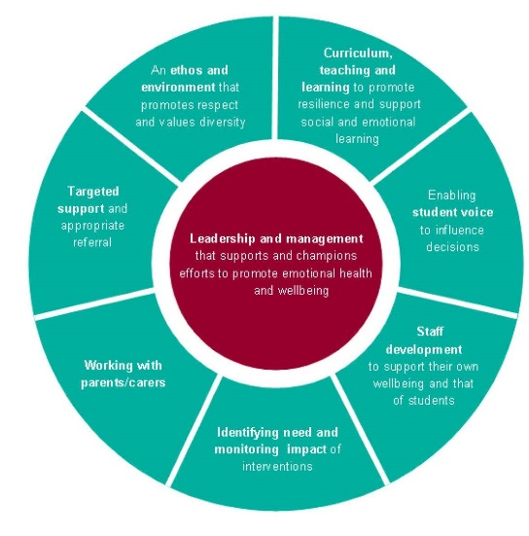
- Online Resources

The Network will be underpinned by the Public Health England’s (2015) ‘Eight Principles of a Whole Schools Approach’. Using the principles, we will be asking schools to create an action plan against each of the key four areas (Personal, Social and Health Education (PSHE); Physical Activity; Social, Emotional and Mental Health (SEMH) and Healthy Eating). Each of the four action plans will be combined and updated at upcoming conferences throughout the year.

Your school was asked to nominate a designated ‘Health and Wellbeing Champion’ to attend conferences to enhance their skills and knowledge. These conferences are designed to showcase the fantastic work already happening within Leicester schools and allows the sharing of good practice. The conferences are developed to inspire the champions by having keynote speakers, developing action plans and interactive workshops.

The Healthy Schools Network also offers four Network Meetings per academic year, each covering one of four key areas; Personal, Social and Health Education (PSHE); Physical Activity; Social, Emotional and Mental Health (SEMH) and Healthy Eating. This gives the network members a chance to share good practice and consists of briefings from professional providers; ensuring schools are aware of the support available in the relevant areas and keeping them updated with current health and wellbeing affairs.

As your schools designated Health and Wellbeing Champion, your role will be the key link between the work of the Healthy Schools Network and its impact on this aspect of the wider curriculum. The role is most effective when information is shared with your school colleagues and school community.

It is widely recognised that a child’s emotional health and wellbeing influences their cognitive development and learning, as well as their physical and social health and their mental wellbeing in adulthood. Therefore, it is important that schools are supported to adopt a comprehensive, ‘whole school’ approach to promoting the social and emotional wellbeing of children and young people.

The schools’ Health and Wellbeing Champions are people who, with training and support, will help others to enjoy healthier lives by raising awareness, sharing messages, removing barriers and creating supportive networks and environments.
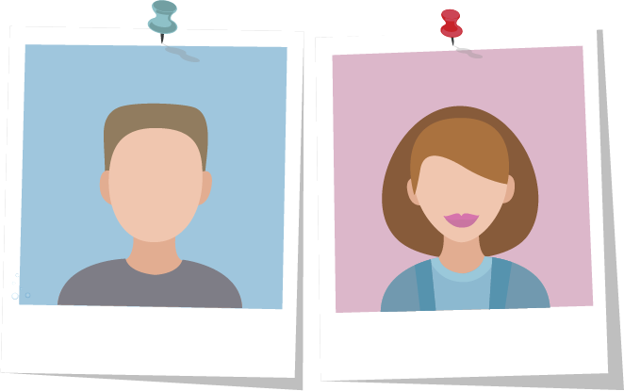
Your Health and Wellbeing Champion should:
- be a positive thinker
- be friendly and approachable
- be enthusiastic and motivated
- be non-judgemental
- be innovative and creative
- care about their own health and the health of others

The Network is offering the designated ‘Health and Wellbeing Champion’ the opportunity to attain an accreditation through the Royal Society Public Health (RSPH) to support their continued professional development.

This Workbook has been designed to allow your school to audit emotional health and wellbeing approaches in the four key areas, create an action plan for a whole school approach and to look at sharing good practice.

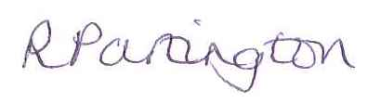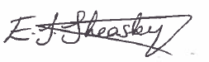

Rebecca Partington, Sophie Carter, Emma Sheasby
Healthy Schools Network Team

*The School Development Support Agency (SDSA) is a not-for-profit organisation which supports school-led improvement. The SDSA are an innovative school support organisation led by experienced education professionals and project managers. The SDSA have a proven track record of contributing to positive outcomes for children and young people.
The Whole School Approach

Healthy Schools takes a whole systems approach with the aim of integrating health and wellbeing within the ethos, culture, routine life and core business of the school setting. This is known as the ‘Whole School Approach’ and involves addressing the needs of pupils, staff and the wider community, not only within the curriculum, but across the whole-school and learning environment.

The whole school approach encompasses these eight over-arching areas of school improvement:
- leadership, management and managing change
- learning and teaching, curriculum planning and resourcing
- school culture and environment including policy development
- giving children and young people a voice
- provision of support services for children and young people
- staff continuing professional development (CPD) needs, health and wellbeing
- partnerships with parents/carers and local communities
- assessing, recording and reporting the achievement of children and young people.

The Whole School Approach provides a model to support change and development involving children, young people, staff, parents/carers and governors.

It also provides a solid foundation from which developments and improvements are embedded in a systematic way throughout the school and effectively contribute to the physical and emotional health and wellbeing of all members of the school community.

By adopting the Whole School Approach schools ensure full engagement with the school community and secure sustainable improvements.

The Eight Principles of a Whole School Approach
(Promoting Children and Young People’s Emotional Health and Well-Being – a Whole School and College Approach, Public Health England and Young People’s Mental Health Coalition, March 2015)

- Leadership and management that supports and champions efforts to promote emotional health and wellbeing
- An ethos and environment that promotes respect and values diversity
- Curriculum, teaching and learning to promote resilience and support social and emotional learning
- Enabling student voice to influence decisions
- Staff development to support their own wellbeing and that od students
- Identifying need and monitoring impact of interventions
- Working with parents/carers
- Targeted support and appropriate referral

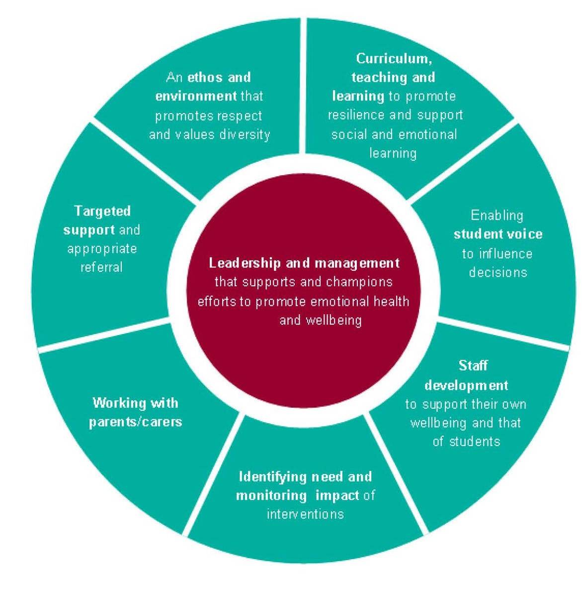
https://www.gov.uk/government/publications/promoting-children-and-young-peoples-emotional-health-and-wellbeing
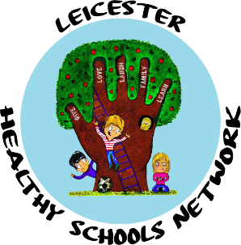

Health and Wellbeing Champions’ Conference Agenda
Young People and Mental Health in a Changing World
Wednesday 10th October 2018
College Court Conference Centre, Knighton Road, Leicester LE2 3TQ

8:45am | Arrival and refreshments
9:00am | Welcome and introductions (action plan, workbook, qualification)
9:30am | Teresa Day, Director: Schools and Families, Charlie Waller Memorial Trust
10:15am | Refreshment break
10:30am | Workshop/Activity with Teresa Day
11:30am | Action plan for a Whole School Approach
12:00pm | Lunch collection and networking opportunities
Teresa Day
Teresa is the Director of Schools and Families programme at the Charlie Waller Memorial Trust (CWMT) and has recently lead a large HEE-funded project focussing on the mental health needs of vulnerable children. Teresa’s other work for CWMT includes parent support projects and developing mental health training to support for whole school communities.

She is passionate about promoting the voice of young people and using creative arts and nature to improve wellbeing.

Teresa has extensive experience writing and developing training resources, and delivering training on emotional wellbeing and mental health for schools and other youth settings.

Teresa has also co-written a drama-based PSHE toolkit for schools which included creating a suite of on-line learning resources and has broad experience (both professional and personal) of the impact that the creative arts and contact with nature can play in promoting wellbeing.

Health and Wellbeing Champions’ Conference Notes

About your school

School Name

What is your schools mission statement?

Who are the lead members of staff responsible for aspects of health and wellbeing at school?

Area | Lead Member
Personal, Social and Health Education (PSHE)
Physical Activity
Social, Emotional and Mental Health (SEMH)
Healthy Eating

Development for this academic year

Yourself | Pupils | Staff | Whole Community
e.g., Developing my understanding of Health & Wellbeing. | e.g., Develop resilience. | e.g., Encourage staff to deliver outstanding PSHE lessons. | e.g., Enhance the knowledge of health and wellbeing to the community

What are the key health and wellbeing policies at your school?
You may wish to list these and keep a note of the date each policy is next due for review.

 | Last Review  Month/Year | Next Review  Month/Year
PSHE education
Sex and relationship education (SRE)
Confidentiality Policy / Statement
Inclusion/Special Educational Needs Policy
E-Safety
Safeguarding Policy
Physical Activity (not just PE)
Anti-bullying (Emotional health & wellbeing)
First Aid & Medication
Food Policy
Behaviour & Discipline
No Smoking Policy & managing drug related incidents
Drug education policy
Travel plan

How confident do you feel?
With 1 representing minimal/no knowledge and 10 representing extensive knowledge

Please circle/colour in how much of an understanding you have around:
 | 1 | 2 | 3 | 4 | 5 | 6 | 7 | 8 | 9 | 10
PSHE
Physical Activity
SEMH
Healthy Eating

Self-assessment Check List

The self-assessment should be completed by the senior leadership team with representation from teachers, SENCO, pastoral staff, children and young people. As you work through the check list you will be asked to consider the extent to which you are achieving each principle and to rate progress accordingly (see table below).

Completing the self-assessment check list will be most valuable if contributors commit to honest self-refection with each other as a way to improve. This approach will also support collective understanding of the social, emotional and mental health challenges, and encourage ownership of actions needed for improvement from an early stage.

The good practice indicators will help guide the discussion in your school or college. As you complete the self-assessment check list you will need to check and challenge your rating by thinking about whether you would be prepared to stand up and defend your rating if scrutinised by other peers. The rating system is intended as a diagnostic tool to help you identify your particular strengths and areas for improvement. You may also wish to use the evidence column to record activities or interventions you feel support your rating.

Red rating
R
No evidence
You might be achieving a few of the good practice Indicators, but there are significant areas where you would want there to be more progress against the principle
Amber rating
A
Some evidence
Achieving most of the good practice indicators, but with room for improvement in some areas of the principle
Green rating
G
Strong evidence
Achieving all or nearly all of the good practice indicators for that principle

- Management and Leadership
Key Question | Indicators of good practice | Score  R A G | Evidence
How is the school or college providing visible senior leadership for emotional health and wellbeing? | Senior leadership ensure efforts to promote emotional health and mental wellbeing are accepted and embedded within the school or college.
 | A named member of the senior leadership team (SLT) has responsibility for emotional health and mental wellbeing.
 | An emotional health and mental wellbeing policy for all children and young people and staff has been developed using a whole school approach. (This should reflect national policy and guidance and include how mental health is dealt with in the school/college, how it is taught, and guidance for staff when dealing with mental health issues).
 | Governors understand emotional health and mental wellbeing issues, and support this agenda.
 | There is commitment from SLT and Governors to address social, emotional and mental wellbeing which is referenced in school or college improvement plans. Pupils, staff and parents are involved in developing policies (such as safeguarding; confidentiality; personal, social and health education (PSHE); social, moral, spiritual and cultural (SMSC) education; behaviour and rewards) so that they remain ‘live’ documents that are reviewed and responsive to the evolving needs of the school community.
There is clear understanding and knowledge of the external support services that are available to provide additional targeted mental health support (see graduated response).

The quality assurance framework for commissioning emotional health and well-being services has been implemented to ensure school /college commissioned external support services are:
• Safe and effective
• Employ qualified practitioners
• Value for money and minimise risk to the school or college

- School/College Ethos and Environment
Key Question | Indicators of good practice | Score  R A G | Evidence
How does the school or college’s culture promote respect and value diversity? | The senior leadership team provides clear leadership to create and manage the physical, social and emotional environment as these impact on staff and pupils/students emotional and mental health wellbeing.
 | There is a safe environment which nurtures and encourages young people’s sense of self-worth and self-efficacy, reduces the threat of bullying and violence and promotes positive behaviours.
 | There is a culture of inclusiveness and communication that ensures all staff and young people’s concerns can be addressed (including the concerns of those who may be at particular risk of poor mental health).
 | There is dedicated staff training, sign posting information (staff and students), PSHE and library resources and targeted mental health campaigns (including tackling stigma and discrimination).

- Curriculum, Teaching and Learning
Key Question | Indicators of good practice | Score  R A G | Evidence
What focus is given within the curriculum to social and emotional learning and promoting personal resilience, and how is learning assessed? | The curriculum promotes positive behaviours and successful relationships and helps reduce disruptive behaviour and bullying. This includes targeted programmes and interventions which:  - Ensure implementation of high-quality programmes and interventions  - Explicitly teach social and emotional skills, attitudes and values, using well-trained and enthusiastic teachers and positive, experiential and interactive methods.  - Integrate this learning into the mainstream processes of school or college life
 | Social and emotional skills development are integrated within all subject areas (these skills include problem solving, coping, conflict management / resolution and understanding and managing feelings).
 | Personal, social and health education (PSHE) and sex and relationships education (SRE) are embedded across the curriculum and culture of the organisation. The school/college’s approach seeks to build emotional skills as well as knowledge, and parents are involved.

- Student Voice
Key Question | Indicators of good practice | Score  R A G | Evidence
How does the school or college ensure all students have the opportunity to express their views and influence decisions? | The senior leadership team recognise children and young people have a powerful voice in learning, decision making, peer led approaches and development of strong social networks (regardless of age and ability).
 | There are a variety of strategies in place to ensure all children and young people are able to contribute to decisions individually or collectively that may impact on their social and emotional wellbeing (regardless of age and ability).
 | Young people and staff work in partnership to formulate, implement and evaluate organisation-wide approaches to promoting social, emotional and mental wellbeing.
 | Children and young people are actively engaged in discussions about emotional health and mental wellbeing provision in their school or college.
 | In secondary education / further education: young people involved in the creation, delivery and evaluation of staff training and continuing professional development activities in relation to social, emotional and mental wellbeing.

- Staff Development, Health and Wellbeing
Key Question | Indicators of good practice | Score  R A G | Evidence
How are staff supported in relation to their own health and wellbeing and to be able to support student wellbeing? | Use of the Government e-learning platform MindEd (www.minded.org.uk/) is promoted
 | Training is provided to staff so that they have the knowledge, understanding and skills to deliver a curriculum that effectively integrates the development of social and emotional skills within subject areas.
 | Training is provided to staff to support children and young people’s social, emotional and psychological wellbeing. This includes identifying and assessing the early signs of anxiety, emotional distress and behavioural problems (including primary school children). Staff are able to assess whether a specialist should be involved and can make an appropriate request using the graduated response.
Support is provided to enable staff to reflect on, and take actions to enhance, their own wellbeing and by promoting a work-life balance for staff.

The workplace charter provides a set of national standards for workplace health (including mental health) (www.wellbeingcharter.org.uk).
 | A system is in place for assessing and monitoring the mental wellbeing of staff as part of professional development and performance reviews. This includes using staff attitude surveys, open conversations to provide feedback and investment in training.

- Identifying Need and Monitoring Impact
Key Question | Indicators of good practice | Score  R A G | Evidence
How does the school or college assess the needs of students and the impact of interventions to improve wellbeing? | A systematic measure is used to assess pupil emotional health and mental wellbeing (including identifying those who need extra support). Assessment outcomes are used as the basis for planning activities and measuring impact.
Data is used effectively to monitor and act on changes in pupils’ patterns of attainment, attendance or behaviour.

There is an effective pastoral system so that at least one member of staff (e.g. a form tutor or class teacher) knows each pupil well and can spot where changes in behaviour may have a root cause that needs addressing.
 | Understanding of pupils’ needs is used to inform commissioning decisions at school / college level or across school clusters.
 | The impact of any support that is put in place is monitored and recorded as per the graduated response.

- Working with Parents, Carers and Community
Key Question | Indicators of good practice | Score  R A G | Evidence
How does the school or college work in partnership with parents and carers to promote emotional health and mental wellbeing? | All pupils and, where appropriate, their parents or carers (including adults with responsibility for looked after children) are engaged in genuine participation, including pupils / students whose families may feel blamed or stigmatised.
 | Parents are provided with information about the school’s policies on promoting social and emotional wellbeing and preventing mental health problems.
 | Parents, carers and other family members living in disadvantaged circumstances are given the support they need to participate fully in activities to promote social and emotional wellbeing. This should include support to participate fully in any parenting sessions, for example by offering a range of times for the sessions or providing help with transport and childcare. This might involve liaison with family support agencies.

8. Coordinated Support
Key Question | Indicators of good practice | Score  R A G | Evidence
How does the school or college ensure timely and effective identification of students who would benefit from coordinated support and ensure an appropriate graduated response is in place? | Specific help for children most at risk (or already showing signs) of social, emotional and behavioural problems.
 | Children who are showing difficulties in managing emotions or behaviour are identified and assessed, using joint problem solving through the Assess-Plan-Do-Review process with the child and their parents/carers and other professionals.
 | An action plan is agreed as the first stage of a graduated response and more intense evidence based work is provided on social and emotional skill development according to the child’s needs.
 | The need for additional external agency involvement is considered through: Assess-Plan-Do-Review cycles e.g. consultation or targeted support.
 | Young people receive clear and consistent information about the opportunities available for them to discuss personal issues and emotional concerns.
 | Availability of pastoral care and support is well known and easy to access.

ACTION PLAN TEMPLATE
(building on the results of the self-assessment)
Key Question | What are we going to do to get better in this area? Think about the things you will have to do in each of the core principles. | Who will do it? Who will do the things you have decided need to be done? | When will it be done by? When do you plan to have completed the action or is there a date you want to review your progress?
How is the school or college providing visible senior leadership for emotional health and mental wellbeing?
How does the school or college’s culture promote respect and value diversity?
What focus is given within the curriculum to social and emotional learning and promoting personal resilience, and how is learning assessed?
How does the school or college ensure timely and effective identification of students who would benefit from targeted support and ensure appropriate referral to support services?
How does the school or college ensure all students have the opportunity to express their views and influence decisions?
How are staff supported in relation to their own health and wellbeing and to be able to support student wellbeing?
How does the school or college assess the needs of students and the impact of interventions to improve wellbeing?
How does the school or college work in partnership with parents and carers to promote emotional health and mental wellbeing?

Personal, Social and Health Education (PSHE)

About PSHE
Personal, Social and Health Education (PSHE) is a non-statutory subject, on the school curriculum, through which pupils develop the knowledge, skills and attributes they need to manage many of the critical opportunities, challenges and responsibilities they will face as they grow up and in adulthood.

Although PSHE is a non-statutory subject, the national curriculum states that all state schools ‘should make provision for personal, social, health education (PSHE), drawing on good practice'. Maintained schools are required to publish details of the curriculum by year group for all subjects, including PSHE. This should be with the same level of detail as for all other subjects. Academies, free schools and independent schools are not bound by the national curriculum, however all schools share the statutory duties. A school’s best approach is therefore to ensure that a comprehensive programme of PSHE is in place.

By teaching pupils to stay safe and be healthy, and by building self-esteem, resilience and empathy, an effective PSHE programme can tackle barriers to learning, raise aspirations, and improve the life chances of the most vulnerable and disadvantaged pupils. Evidence shows that well-delivered PSHE can address teenage pregnancy, substance misuse, unhealthy eating, lack of physical activity, and emotional health.

In July 2018, the government announced that all schools will have to teach Relationships and Sex Education (secondary)/Relationships Education (primary) and health education. The relationships and health aspects of PSHE education will be compulsory in all schools from 2020.

Included in what will be delivered:
- features of healthy friendships, family relationships and other relationships
- how relationships can affect physical and mental health
- staying safe online
- how to use technology safely, responsibly and respectfully
- how to keep personal information private
- healthy eating
- keeping fit
- prevention of health problems
- recognition of mental health and ways to support good mental health
- consent
- development of qualities such as confidence, resilience, self-respect
- wider social and economic issues

PSHE covers a range of topics including:

- Statutory RSE and PSHE
- Drug Education
- Personal Safety Education
- Relationships and sex education
- Social norms
- Financial education
- Physical activity
- Diet for a healthy lifestyle

On the next few pages you will find the following tools to investigate gaps and good practice that your school carries out as a Whole School approach.
- School Audit
- Action Plan
- Sharing Good Practice Template

Personal, Social and Health Education (PSHE) School Audit

Think about what PSHE activities your school currently covers, what it has covered in the past and what you would like to try in the future.
Remember there will be cross over between the four key areas.

What have you done in the past 12 months? | What do you currently do? | What would you like to try?
Barriers and Obstacles | Barriers and Obstacles | Barriers and Obstacles

Personal, Social and Health Education (PSHE) Action Plan

Area of Health and Wellbeing | Change/improvement to see | Date to achieve this by | Key decision maker and how to influence | Other key people and how to influence | Barriers and Obstacles
Leadership and management
Ethos and environment
Curriculum, teaching and learning
Student voice

Area of Health and Wellbeing | Change/improvement to see | Date to achieve this by | Key decision maker and how to influence | Other key people and how to influence | Barriers and Obstacles
Staff development
Identifying need and monitoring impact
Working with parents/carers
Targeted support

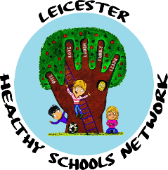
School Logo can be added here
PROJECT TITLE
EXAMPLE Primary School
Health and Wellbeing Champion NAME
PROJECT AIM:

WHAT YOU DO
and
WHAT WAS INVOLVED
and
HOW YOU DID IT

IMPACT

IMAGE
NEXT STEPS
Physical Activity
About Physical Activity
Physical Activity is an integral part of daily life in a health-promoting school and can contribute to the physical, social and emotional wellbeing of all children, young people and staff within the school community.

Engaging in regular Physical Activity and eating well are extremely important in helping to maintain a healthy body weight.

Schools can use the Healthy School criteria to provide evidence that there is a sustainable whole-school approach to Physical Activity.

Any type of Physical Activity is beneficial, and just encouraging children and young people to reduce the amount of time they spend sitting or being inactive is a good starting point.

Children and young people aged 5-18 should engage in moderate to vigorous intensity physical activity for at least 60 minutes and up to several hours a day.
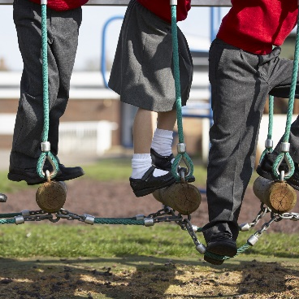
The greatest benefits come from engaging in a broad range of Physical Activity including:
- PE lessons
- sports
- dance
- outdoor activities
- exercise and training sessions
- walking/jogging
- cycling
- skateboarding
- active play
- roller blading
- The Daily Mile
- Road Safety Education

On the next few pages you will find the following tools to investigate gaps and good practice that your school carries out as a Whole School approach.
- School Audit
- Action Plan
- Sharing Good Practice Template
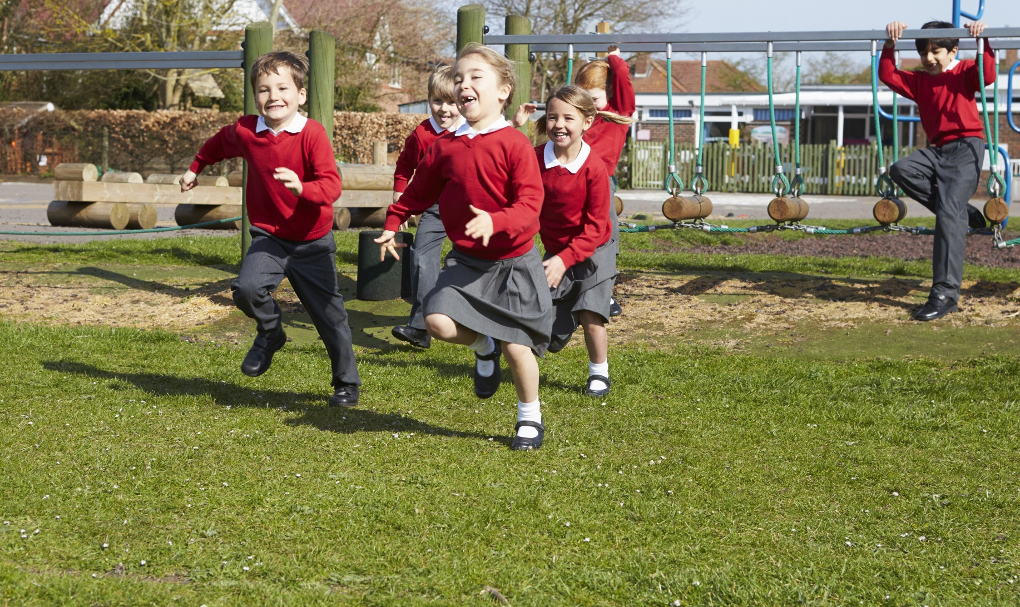

Physical Activity School Audit

Think about what Physical Activity activities your school currently covers, what it has covered in the past and what you would like to try in the future.
Remember there will be cross over between the four key areas.

What have you done in the past 12 months? | What do you currently do? | What would you like to try?
Barriers and Obstacles | Barriers and Obstacles | Barriers and Obstacles
Physical Activity Action Plan

Area of Health and Wellbeing | Change/improvement to see | Date to achieve this by | Key decision maker and how to influence | Other key people and how to influence | Barriers and Obstacles
Leadership and management
Ethos and environment
Curriculum, teaching and learning
Student voice

Area of Health and Wellbeing | Change/improvement to see | Date to achieve this by | Key decision maker and how to influence | Other key people and how to influence | Barriers and Obstacles
Staff development
Identifying need and monitoring impact
Working with parents/carers
Targeted support

School Logo can be added here
PROJECT TITLE
EXAMPLE Primary School
Health and Wellbeing Champion NAME
PROJECT AIM:

WHAT YOU DO
and
WHAT WAS INVOLVED
and
HOW YOU DID IT

IMPACT

IMAGE
NEXT STEPS
Social, Emotional and Mental Health (SEMH)

About SEMH
A focus on Emotional Health and Wellbeing is critical to the social development and educational achievement of children and young people. To reflect this, schools have had a duty to promote health and wellbeing since 2007.

Children and young people need to be able to bounce back when life gets tough. It is important for them to be able to manage their emotions and behaviour in an appropriate way.

What are the characteristics of a child- friendly school?
- reflects and realises the rights of every child;
- sees and understands the whole child in a broad context;
- is child-centred;
- is gender sensitive;
- promotes quality learning outcomes;
- provides education based on the reality of children's lives;
- is flexible and responds to diversity;
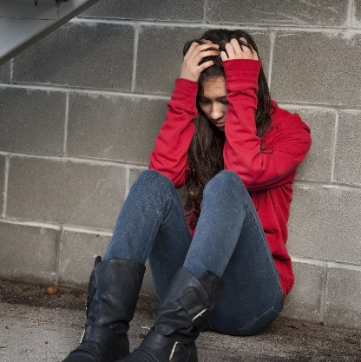
- acts to ensure inclusion, respect and equality of opportunity for all children;
- promotes mental and physical health;
- enhances teacher capacity, morale, commitment and status;
- is family focused;
- is community based.

SEMH covers a range of topics including:
- Social and emotional functioning
- Wellbeing
- The ability to regulate self and behaviour
- Mental Health difficulties
- Anti-bullying practice
- Healthy Mind Healthy Life
- Self-harm
- Supporting young carers
- Reading Well
- Staff wellbeing
- Young listeners

On the next few pages you will find the following tools to investigate gaps and good practice that your school carries out as a Whole School approach.
- School Audit
- Action Plan
- Sharing Good Practice Template

Social, Emotional and Mental Health (SEMH) School Audit

Think about what SEMH activities your school currently covers, what it has covered in the past and what you would like to try in the future.
Remember there will be cross over between the four key areas.

What have you done in the past 12 months? | What do you currently do? | What would you like to try?
Barriers and Obstacles | Barriers and Obstacles | Barriers and Obstacles
Social, Emotional and Mental Health (SEMH) Action Plan

Area of Health and Wellbeing | Change/improvement to see | Date to achieve this by | Key decision maker and how to influence | Other key people and how to influence | Barriers and Obstacles
Leadership and management
Ethos and environment
Curriculum, teaching and learning
Student voice

Area of Health and Wellbeing | Change/improvement to see | Date to achieve this by | Key decision maker and how to influence | Other key people and how to influence | Barriers and Obstacles
Staff development
Identifying need and monitoring impact
Working with parents/carers
Targeted support

School Logo can be added here
PROJECT TITLE
EXAMPLE Primary School
Health and Wellbeing Champion NAME
PROJECT AIM:

WHAT YOU DO
and
WHAT WAS INVOLVED
and
HOW YOU DID IT

IMPACT

IMAGE
NEXT STEPS
Healthy Eating
About Healthy Eating
Good eating habits are developed during childhood. If encouraged to enjoy healthier food and drink early on, it is more likely that these positive behaviours will remain with children and young people throughout life.

Children and young people spend, on average, a quarter of their waking lives in schools, so schools can have a positive influence over their knowledge, experience and behaviour. The knowledge developed in the classroom about a healthier diet, the food that is offered and promoted throughout the school day, as well as the attitude of the whole school community, can have a major influence on children and young people. The lifelong learning skills they need to make appropriate food choices and to develop a positive attitude towards diet and health can all be influenced at school.

It is important that messages about healthy eating and healthy lifestyles are consistent. Schools can help provide these and, by involving the whole school community, they can help encourage healthier behaviour outside of the school environment as well.

Schools that have completed the Food for Life Award will already have useful evidence that they contribute to network meetings to help others.

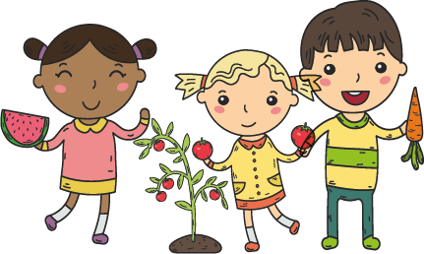
Healthy Eating covers a range of topics including:
- The National Child Measurement Programme
- Healthy Pupil Capital fund
- Healthy Eating
- Healthy Me

On the next few pages you will find the following tools to investigate gaps and good practice that your school carries out as a Whole School approach.
- School Audit
- Action Plan
- Sharing Good Practice Template

Healthy Eating School Audit

Think about what Healthy Eating activities your school currently covers, what it has covered in the past and what you would like to try in the future. Remember there will be cross over between the four key areas.

What have you done in the past 12 months? | What do you currently do? | What would you like to try?
Barriers and Obstacles | Barriers and Obstacles | Barriers and Obstacles
Healthy Eating Action Plan

Area of Health and Wellbeing | Change/improvement to see | Date to achieve this by | Key decision maker and how to influence | Other key people and how to influence | Barriers and Obstacles
Leadership and management
Ethos and environment
Curriculum, teaching and learning
Student voice

Area of Health and Wellbeing | Change/improvement to see | Date to achieve this by | Key decision maker and how to influence | Other key people and how to influence | Barriers and Obstacles
Staff development
Identifying need and monitoring impact
Working with parents/carers
Targeted support

School Logo can be added here
PROJECT TITLE
EXAMPLE Primary School
Health and Wellbeing Champion NAME
PROJECT AIM:

WHAT YOU DO
and
WHAT WAS INVOLVED
and
HOW YOU DID IT

IMPACT

IMAGE
NEXT STEPS
Whole School Approach to a Healthy School

Now that you have looked at the four key areas and identified change and improvement needed are there any overlapping themes that could be addressed as a whole school? Are there any barriers and obstacles that need to be addressed? Do you know what to do in order to overcome the barriers and obstacles? Complete this action plan using all four key areas.

Area of Health and Wellbeing | Change/improvement to see | Date to achieve this by | Key decision maker and how to influence | Other key people and how to influence | Barriers and Obstacles
Leadership and management
Ethos and environment
Curriculum, teaching and learning
Student voice

Area of Health and Wellbeing | Change/improvement to see | Date to achieve this by | Key decision maker and how to influence | Other key people and how to influence | Barriers and Obstacles
Staff development
Identifying need and monitoring impact
Working with parents/carers
Targeted support

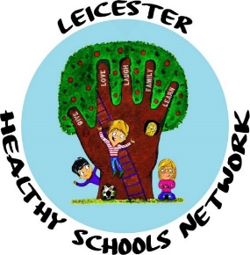
PSHE Network Meeting
Thursday 15th November 2018
1:15pm-3:15pm
Venue: SDSA Training Room, 1st Floor, Alliance House, 6 Bishop Street, Leicester LE1 6AF
Subject to change

Time | Activity
1:15pm-1:30pm | Refreshments and Networking
1:30pm-1:45pm | Welcome from the SDSA and activity
1:45pm-2:05pm | Air Quality Education  Danielle Kennell
2:00pm-2:30pm | Jigsaw  Jan Lever and Angela Milliken
2:30pm-3:00pm | Relationships and Sex Education (RSE)  Julie Eason  (Midlands Partnership NHS Foundation Trust)
3:00pm-3:15pm | Reflections/Networking  Finish and close by SDSA

Network Meeting Notes

Physical Activity Network
Tuesday 15th January 2019
3:30pm-5:30pm
Venue: Crown Hills Community College, Gwendolen Rd, Leicester LE5 5FT
Subject to change

Time | Activity
3:30pm-3:45pm | Refreshments and Networking
3:45pm-4:00pm | Welcome from the SDSA and activity
4:00pm-4:15pm | Crown Hills Community College
4:15pm – 4:45pm | Mindful Warriors
4:45pm-5:15pm | TBC
5:15pm-5:30pm | Finish and close by SDSA

Network Meeting Notes

SEMH Network Meeting
Thursday 14th February 2019
1:15pm-3:15pm
Venue: Eyres Monsell Primary School, Simmins Crescent, Leicester LE2 9AH
Subject to change

Time | Activity
1:15pm-1:30pm | Refreshments and Networking
1:30pm-1:45pm | Welcome from the SDSA and activity
1:45pm-2:15pm | Eyres Monsell Primary School
2:15pm-2:40pm | M is 4 Mindfulness  Michelle Dredger
2:40pm-3:10pm | Leicester Children's Hospital School
3:10pm-3:15pm | Finish and close by SDSA

Network Meeting Notes

Health and Wellbeing Champions’ Conference Agenda
Health and Wellbeing in a School Environment
Monday 25th March 2019
Leicester Racecourse, Leicester Road, Oadby, Leicester LE2 4AL
8:45am | Arrival and refreshments |  | All Leicester City Schools
9:00am | Welcome and introductions/updates
9:15am | Marketplace
10:15am | Refreshment break
10:30am | Keynote Speaker
11:30am | Workshop (x4)
12:00pm | Lunch and Marketplace
1:00pm | Workshop (x4) |  | HSN Members ONLY
1:30pm | Keynote Speaker
2:30pm | Action planning for Whole School Approach
3:00pm | Finish and close (networking opportunities)
Health and Wellbeing Champions’ Conference Notes

Healthy Eating Network Meeting
Thursday 23rd May 2019
3:30pm-5:30pm
Venue: SDSA Training Room, 1st Floor, Alliance House, 6 Bishop Street, Leicester LE1 6AF
Subject to change

Time | Activity
3:30pm-3:45pm | Refreshments and Networking
3:45pm-4:00pm | Welcome from the SDSA and activity
4:00pm-4:30pm | Healthy Eating 4 Schools  Lucy Marsden
4:30pm-5:00pm | TBC
5:00pm-5:25pm | Leicester Tigers Health Education  Ashleigh Theobald
5:25pm-5:30pm | Finish and close by SDSA

Network Meeting Notes

Health and Wellbeing Champions’ Conference Agenda
Looking Back, Looking Forwards
Tuesday 25th June 2019, Stamford Court

8:45am | Arrival and refreshments
9:00am | Welcome and introductions/updates
9:15am | Keynote speaker with activity
10:15am | Refreshment break
10:30am | Schools sharing good practice
12:00pm | Lunch collection and networking opportunities

How confident do you feel now?
With 1 representing minimal/no knowledge and 10 representing extensive knowledge

Please circle/colour in how much of an understanding you have around:
 | 1 | 2 | 3 | 4 | 5 | 6 | 7 | 8 | 9 | 10
PSHE
Physical Activity
SEMH
Healthy Eating

Health and Wellbeing Champions’ Conference Notes

Leicester
Healthy Schools Network

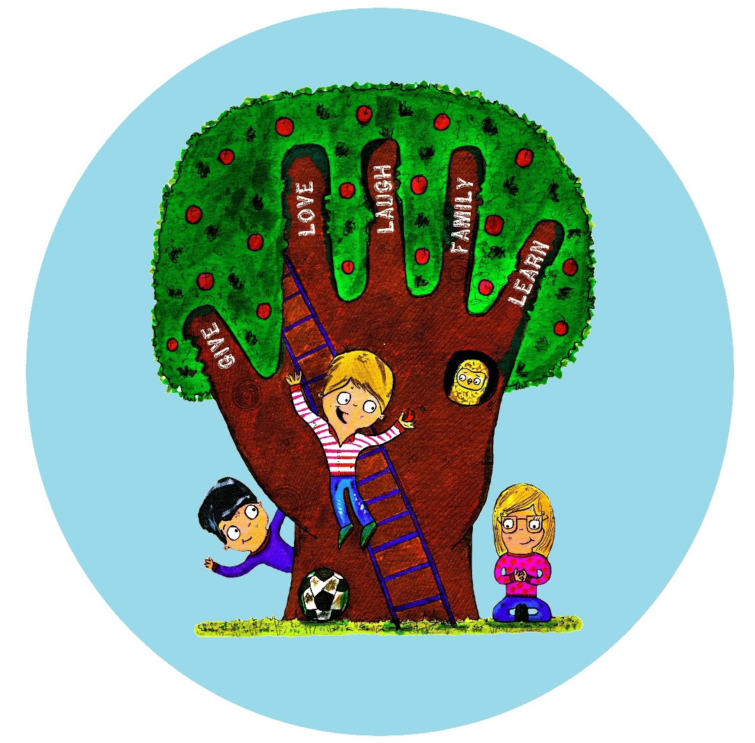
Healthy Schools Network
School Development Support Agency (SDSA)
1st Floor | Alliance House | 6 Bishop Street | Leicester | LE1 6AF
0116 299 5942 | office@sdsa.net

