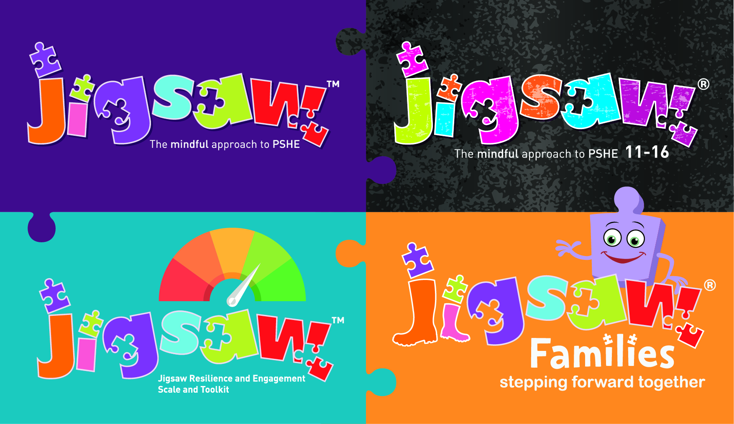

Are you ready for Relationships, Sex and Health Education (RSHE)?

Quick Audit - Primary

Section 1 |  | Yes | In  development | Not  started
Policy & Preparation | Do you have a PSHE policy?  Has it been updated to reflect new guidance?  Does your policy reflect the needs of your setting?  Is there a named lead for PSHE?  In the development of policy do you consult with:  - Parents  - Students  - Teachers  Does your policy consider:  - SEND needs  - LGBTQ+ needs  - Right to withdraw  - Duties on schools such as the Equality Act, safeguarding etc?
Section 2 Content | Do you have good quality resources in place to support?  Do resources link to SMSC & British values?  Do RSHE resources consider the following (these statements are taken directly from the new DfE guidance:  Relationships  Families and people who care for me  - That families are important for children growing up because they can give love, security and stability.  - The characteristics of healthy family life, commitment to each other, including in times of difficulty, protection and care for children and other family members, the importance of spending time together and sharing each other’s lives.  - That others’ families, either in school or in the wider world, sometimes look different from their family, but that they should respect those differences and know that other children’s families are also characterised by love and care.  - That stable, caring relationships, which may be of different types, are at the heart of happy families, and are important for children’s security as they grow up  - That marriage represents a formal and legally recognised commitment of two people to each other which is intended to be lifelong.  - How to recognise if family relationships are making them feel unhappy or unsafe, and how to seek help or advice from others if needed.  Caring friendships  - How important friendships are in making us feel happy and secure, and how people choose and make friends.  - the characteristics of friendships, including mutual respect, truthfulness, trustworthiness, loyalty, kindness, generosity, trust, sharing interests and experiences and support with problems and difficulties.  - that healthy friendships are positive and welcoming towards others, and do not make others feel lonely or excluded.  - that most friendships have ups and downs, and that these can often be worked through so that the friendship is repaired or even strengthened, and that resorting to violence is never right.  - How to recognise who to trust and who not to trust, how to judge when a friendship is making them feel unhappy or uncomfortable, managing conflict, how to manage these situations and how to seek help or advice from others, if needed.  Respectful relationships  The importance of respecting others, even when they are very different (for example, physically, in character, personality or backgrounds) or make different choices or have different preferences or beliefs.  Practical steps they can take in a range of different contexts to improve or support respectful relationships.  The convention s of courtesy and manners.  The importance of self-respect and how this links to their own happiness.  That in school and in wider society they can expect to be treated with respect by others, and that in turn they should show due respect to others including those in positions of authority.  About different types of bullying (including cyberbullying), the impact of bullying, responsibilities of bystanders (primarily reporting bullying to an adult) and how to get help.  What a stereotype is, and how stereotypes can be unfair, negative or destructive.  The importance of permission-seeking and giving in relationships with friends, peers and adults.  Online relationships  That people sometimes behave differently online, including pretending to be someone they are not.  That the same principles apply to online relationships as to face-to-face relationships, including g the importance of respect for others online including when we are anonymous.  The rules and principles for keeping safe online, how to recognise risks, harmful content and contact and how to report them.  How to critically consider their online friendships and sources of information including awareness of the risks associated with people they have never met.  How information and data is shared and used online.  Being safe  - What sort of boundaries are appropriate in friendships with peers and others (including in a digital context).  - About the concept of privacy and the implications of it for both children and adults; including that it is not always right to keep secrets if they relate to being safe.  - That each person’s body belongs to them, and the differences between appropriate and inappropriate or unsafe physical, and other, contact.  - How to respond safely and appropriately to adults they may encounter (in all contexts, including online) whom they do not know.  - How to recognise and report feelings of being unsafe or feeling bad about any adult.  - How to ask for advice or help for themselves or others, and to keep trying until they are heard.  - How to report concerns or abuse, and the vocabulary and confidence needed to do so.  - Where to get advice e.g. family, school and/or other sources.  Health Education: physical health and mental wellbeing  Mental wellbeing  - that mental wellbeing is a normal part of daily life, in the same way as physical wellbeing.  - That there is a normal range of emotions (e.g. happiness, sadness, anger, fear, surprise, nervousness) and a scale of emotions that all humans experience in relation to different experiences and situations.  - How to recognise and talk about their emotions, including having a varied vocabulary of words to use when talking about their own and others’ feelings.  - How to judge whether what they are feeling and how they are behaving is appropriate and proportionate.  - The benefits of physical exercise, time outdoors, community participation, voluntary and service-based activity on mental wellbeing and happiness.  - Simple self-care techniques, including the importance of rest, time spent with friends and family and the benefits of hobbies and interests.  - Isolation and lonliness can affect children and that it is very important for children to discuss their feelings with an adult and seek support.  - That bullying (including cyberbullying) has a negative and often lasting impact on mental wellbeing.  - Where and how to seek support (including recognising the triggers for seeking support), including whom in school they should speak to if they are worried about their own or someone else’s mental wellbeing or ability to control their emotions (including issues arising online).  - It is common for people to experience mental ill health. For many people who do, the problems can be resolved if the right support is made available, especially if accessed early enough.  Internet safety and harms  - That for most people the internet is an integral part of life and has many benefits.  - About the benefits of rationing time spent online, the risks of excessive time spent on electronic devices and the impact of positive and negative content online on their own and others’ mental and physical wellbeing.  - How to consider the effect of their online actions on others and know how to recognise and display respectful behaviour online and the importance of keeping personal information private.  - Why social media, some computer games and online gaming, for example, are age restricted.  - That the internet can also be a negative place where online abuse, trolling, bullying and harassment can take place, which can have a negative impact on mental health.  - How to be a discerning consumer of information online including understanding that information, including that from search engines is ranked, selected and targeted.  - Where and how to report concerns and get support with issues online.  Physical health and fitness  - the characteristics and mental and physical benefits of an active lifestyle.  - the importance of building regular exercise into daily and weekly routines and how to achieve this; for example, walking or cycling to school, a daily mile or other forms of regular vigorous exercise.  - the risks associated with an inactive lifestyle (including obesity).  - How and when to seek support including which adults to speak to in school if they are worried about their health.  Healthy eating  - what constitutes a healthy diet (including understanding calories and other nutrition content)  - the principles of planning and preparing a range of healthy meals.  - The characteristics of a poor diet and risks associated with unhealthy eating (including, for example, obesity and tooth decay) and other behaviours (e.g. the impact of alcohol on diet and health)  Drugs, alcohol and tobacco  - The facts about legal and illegal harmful substances and associated risks, including smoking, alcohol use and drug taking.  Health and prevention  - How to recognise early signs of physical illness such as weight loss or unexplained changes to the body.  - about safe and unsafe exposure to the sun and how to reduce the risk of sun damage, including skin cancer  - the importance of sufficient, good quality sleep for good health and that a lack of sleep can affect weight, mood and the ability to learn.  - About dental health and the benefits of good oral hygiene and dental flossing, including regular check-ups at the dentist.  - About personal hygiene and germs, including bacteria, viruses, how they are spread and treated, and the importance of hand washing.  - The facts and science relating to immunisation and vaccination.  Basic first aid  - How to make a clear and efficient call to emergency services if necessary.  - Concepts of basic first-aid, for example dealing with common injuries, including head injuries  Changing adolescent body  - key facts about puberty, the changing adolescent body, particularly from age 9 through to age 11, including physical and emotional changes.  - About menstrual wellbeing including the key facts about the menstrual cycle.
Section 3  Inclusion | - Is the content of your RHE inclusive and relevant for students across the LGBTQ+ spectrum?  - Is the content of your RHE programme inclusive for students with SEND?
Section 4  Progress | Do you have measures in place to review development and progress of students in relation to relationships, sex education and health?
Sections 5  School Ethos | Do you have a “whole school” approach to PSHE?  Are there timetabled lessons for all year groups?  Do you gather data from students to gain insight to needs and how best to meet those needs?

