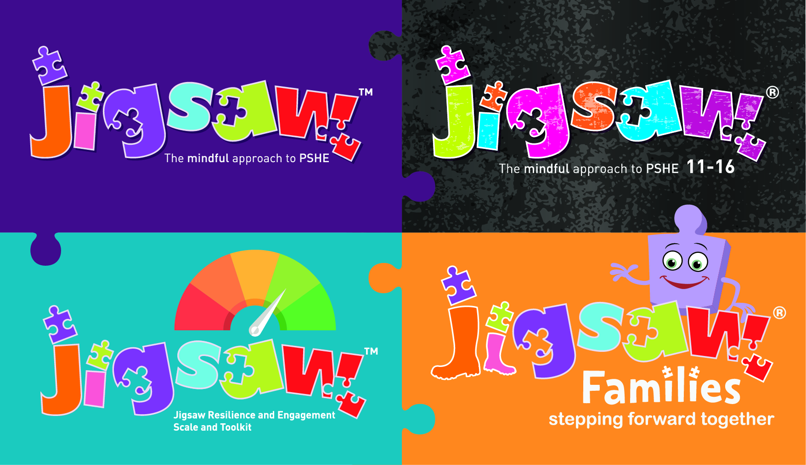

Are you ready for Relationships, Sex and Health Education (RSHE)?

Quick Audit - Secondary

Section 1 |  | Yes | In  development | Not  started
Policy & Preparation | Do you have a PSHE policy?  Has it been updated to reflect new guidance?  Does your policy reflect the needs of your setting?  Is there a named lead for PSHE?  In the development of policy do you consult with:  - Parents  - Students  - Teachers  Do you know what RSHE students have covered in primary school?  Does your policy consider:  - SEND needs  - LGBTQ+ needs  - Right to withdraw  - Duties on schools such as the Equality Act, safeguarding etc?
Section 2 Content | Do you have good quality resources in place to support?  Do resources link to SMSC & British values?  Do RSHE resources consider the following (these statements are taken directly from the new DfE guidance:  Relationships and Sex Education  Families  - that there are different types of committed, stable relationships.  - how these relationships might contribute to human happiness and their importance for bringing up children.  - what marriage is, including their legal status e.g. that marriage carries legal rights and protections not available to couples who are cohabiting or who have married, for example, in an unregistered religious ceremony.  - the characteristics and legal status of other types of long-term relationships.  - why marriage is an important relationship choice for many couples and why it must be freely entered into.  - the roles and responsibilities of parents with respect to raising of children, including the characteristics of successful parenting.  - how to: determine whether other children, adults or sources of information are trustworthy: judge when a family, friend, intimate or other relationship is unsafe (and to recognise this in others’ relationships); and, how to seek help or advice, including reporting concerns about others, if needed.  Respectful relationships, including friendships  - the characteristics of positive and healthy friendships (in all contexts, including online) including: trust, respect, honesty, kindness, generosity, boundaries, privacy, consent and the management of conflict, reconciliation and ending relationships. This includes different (non-sexual) types of relationship.  - practical steps they can take in a range of different contexts to improve or support respectful relationships  - how stereotypes, in particular stereotypes based on sex, gender, race, religion, sexual orientation or disability, can cause damage (e.g. how they might normalise non-consensual behaviour or encourage prejudice).  - that in school and in wider society they can expect to be treated with respect by others, and that in turn they should show due respect to others, including people in positions of authority and due tolerance of other people’s beliefs.  - about different types of bullying (including cyberbullying), the impact of bullying, responsibilities of bystanders to report bullying and how and where to get help.  - that some types of behaviour within relationships are criminal, including violent behaviour and coercive control.  - what constitutes sexual harassment and sexual violence and why these are always unacceptable.  - the legal rights and responsibilities regarding equality (particularly with reference to the protected characteristics as defined in the Equality Act 2010) and that everyone is unique and equal.  Online and media  - their rights, responsibilities and opportunities online, including that the same expectations of behaviour apply in all contexts, including online.  - about online risks, including that any material someone provides to another has the potential to be shared online and the difficulty of removing potentially compromising material placed online.  - not to provide material to others that they would not want shared further and not to share personal material which is sent to them.  - the impact of viewing harmful content.  - that specifically sexually explicit material e.g. pornography presents a distorted picture of sexual behaviours, can damage the way people see themselves in relation to others and negatively affect how they behave towards sexual partners.  - that sharing and viewing indecent images of children (including those created by children) is a criminal offence which carries severe penalties including jail.  - how information and data is generated, collected, shared and used online.  Being safe  - the concepts of, and laws relating to, sexual consent, sexual exploitation, abuse, grooming, coercion, harassment, rape, domestic abuse, forced marriage, honour-based violence and FGM, and how these can affect current and future relationships.  - how people can actively communicate and recognise consent from others, including sexual consent, and how and when consent can be withdrawn (in all contexts, including online).  Intimate and sexual relationships, including sexual health  - how to recognise the characteristics and positive aspects of healthy one-to-one intimate relationships, which include mutual respect, consent, loyalty, trust, shared interests and outlook, sex and friendship.  - the facts about the full range of contraceptive choices, efficacy and options available  - that all aspects of health can be affected by choices they make in sex and relationships, positively or negatively, e.g. physical, emotional, mental, sexual and reproductive health and wellbeing.  - the facts about reproductive health, including fertility and the potential impact of lifestyle on fertility for men and women.  - that there are a range of strategies for identifying and managing sexual pressure, including understanding peer pressure, resisting pressure and not pressurising others.  - that they have a choice to delay sex or to enjoy intimacy without sex.  - that there are choices in relation to pregnancy (with medically and legally accurate, impartial information on all options, including keeping the baby, adoption, abortion and where to get further help).  - how the different sexually transmitted infections (STIs), including HIV/AIDs, are transmitted, how risk can be reduced through safer sex (including through condom use) and the importance of and facts about testing.  - about the prevalence of some STIs, the impact they can have on those who contract them and key facts about treatment.  - how to get further advice, including how and where to access confidential sexual and reproductive health advice and treatment  Health Education: physical health and mental wellbeing  Mental wellbeing  - how to talk about their emotions accurately and sensitively, using appropriate vocabulary  - that happiness is linked to being connected to others  - how to recognise the early signs of mental wellbeing concerns  - common types of mental ill health (e.g. anxiety and depression  - how to critically evaluate when something they do or are involved in has a positive or negative effect on their own or others’ mental health  Internet safety and harms  - the similarities and differences between the online world and the physical world, including: the impact of unhealthy or obsessive comparison with others online (including through setting unrealistic expectations for body image, how people may curate a specific image of their life online, over-reliance on online relationships including social media, the risks related to online gambling including the accumulation of debt, how advertising and information is targeted at them and how to be a discerning consumer of information online  - how to identify harmful behaviours online (including bullying, abuse or harassment) and how to report, or find support, if they have been affected by those behaviours.  Physical health and fitness  - the positive associations between physical activity and promotion of mental wellbeing, including as an approach to combat stress  - the characteristics and evidence of what constitutes a healthy lifestyle, maintaining a healthy weight, including the links between an inactive lifestyle and ill health, including cancer and cardiovascular ill-health  Healthy eating  - how to maintain healthy eating and the links between a poor diet and health risks, including tooth decay and cancer.  Drugs, alcohol and tobacco  - the facts about legal and illegal drugs and their associated risks, including the link between drug use, and the associated risks, including the link to serious mental health conditions  - the law relating to the supply and possession of illegal substances  - the physical and psychological risks associated with alcohol consumption and what constitutes low risk alcohol consumption in adulthood.  - the physical and psychological consequences of addiction, including alcohol dependency  - awareness of the dangers of drugs which are prescribed but still present serious health risks.  - the facts about the harms from smoking tobacco (particularly the link to lung cancer), the benefits of quitting and how to access support to do so  Health and prevention  - about personal hygiene, germs including bacteria, viruses, how they are spread, treatment and prevention of infection, and about antibiotics  - about dental health and the benefits of good oral hygiene and dental flossing, including healthy eating and regular check-ups at the dentist.  - (late secondary) the benefits of regular self-examination and screening.  - the facts and science relating to immunisation and vaccination.  - the importance of sufficient good quality sleep for good health and how a lack of sleep can affect weight, mood and ability to learn  Basic first aid  - basic treatment for common injuries  - life-saving skills, including how to administer CPR  - the purpose of defibrillators and when one might be needed  Changing adolescent body  - key facts about puberty, the changing adolescent body and menstrual wellbeing  - the main changes which take place in males and females, and the implications for emotional and physical health
Section 3  Inclusion | - Is the content of your RSHE inclusive and relevant for students across the LGBTQ+ spectrum?  - Is the content of your RSHE programme inclusive for students with SEND?
Section 4  Progress | Do you have measures in place to review development and progress of students in relation to relationships, sex education and health?
Sections 5  School Ethos | Do you have a “whole school” approach to PSHE?  Are there timetabled lessons for all year groups?  Do you gather data from students to gain insight to needs and how best to meet those needs?

