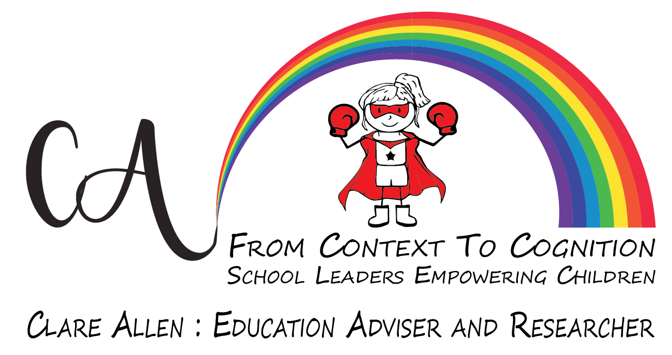
Fee Schedule - 1st January 2020
Services | Fee | Duration | Notes
Consulting, training, research & advisory support* | £350 -£450 | Per day | 6 hours
 | £250 - £275 | Per half day | 3 hours
Twilight training delivery* | £100 | Per hour | (minimum 2 hours)
Preparation of bespoke training material | £60 | Per hour | Per hour
Telephone consultation and 1-2-1 peer support, mentoring and coaching | £60 | Per hour | Per hour
On site consultation and 1-2-1 peer support, mentoring and coaching | £100 | Per hour | (minimum 2 hours)
Conference presentations & workshops* | £350 -£450 | Per day | 6 hours
 | £250 - £275 | Per half day | 3 hours
Conference Keynote | POA
External Review of Governance (ERG) | £950
Pupil Premium Review (PPR) | £950
Governance Review Package* | £1500
Travel & expenses | 45p | per mile
* Subject to preparation time.
Please do call for a quote and to discuss your school development needs.
I look forward to working with you.

Kind regards
Clare

Clare Allen
Tel: 07967 171555
Email: clare@context2cognition.co.uk
www.context2cognition.co.uk

