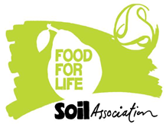

Commissioned by Leicester City Council in partnership with ‘Food for Life’ (FFL).

**Once you have joined Food for Life, Food Route** can support your school with:

* Carry out packed lunch audits and work around healthy packed lunches (virtual option available if preferred)
* Work with your SNAG group and staff
* Help you with healthy changes to packed lunches brought from home
* Offer resources which support you to embed healthy food into school life

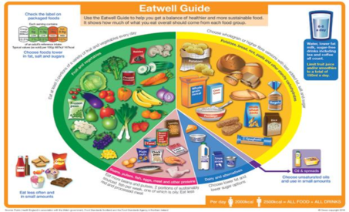

Contact :Food Route Nutritionist Jill Tipple

email [jill.tipple@lnds.nhs.uk](mailto:jill.tipple@lnds.nhs.uk) or phone Tel 0116 2950332