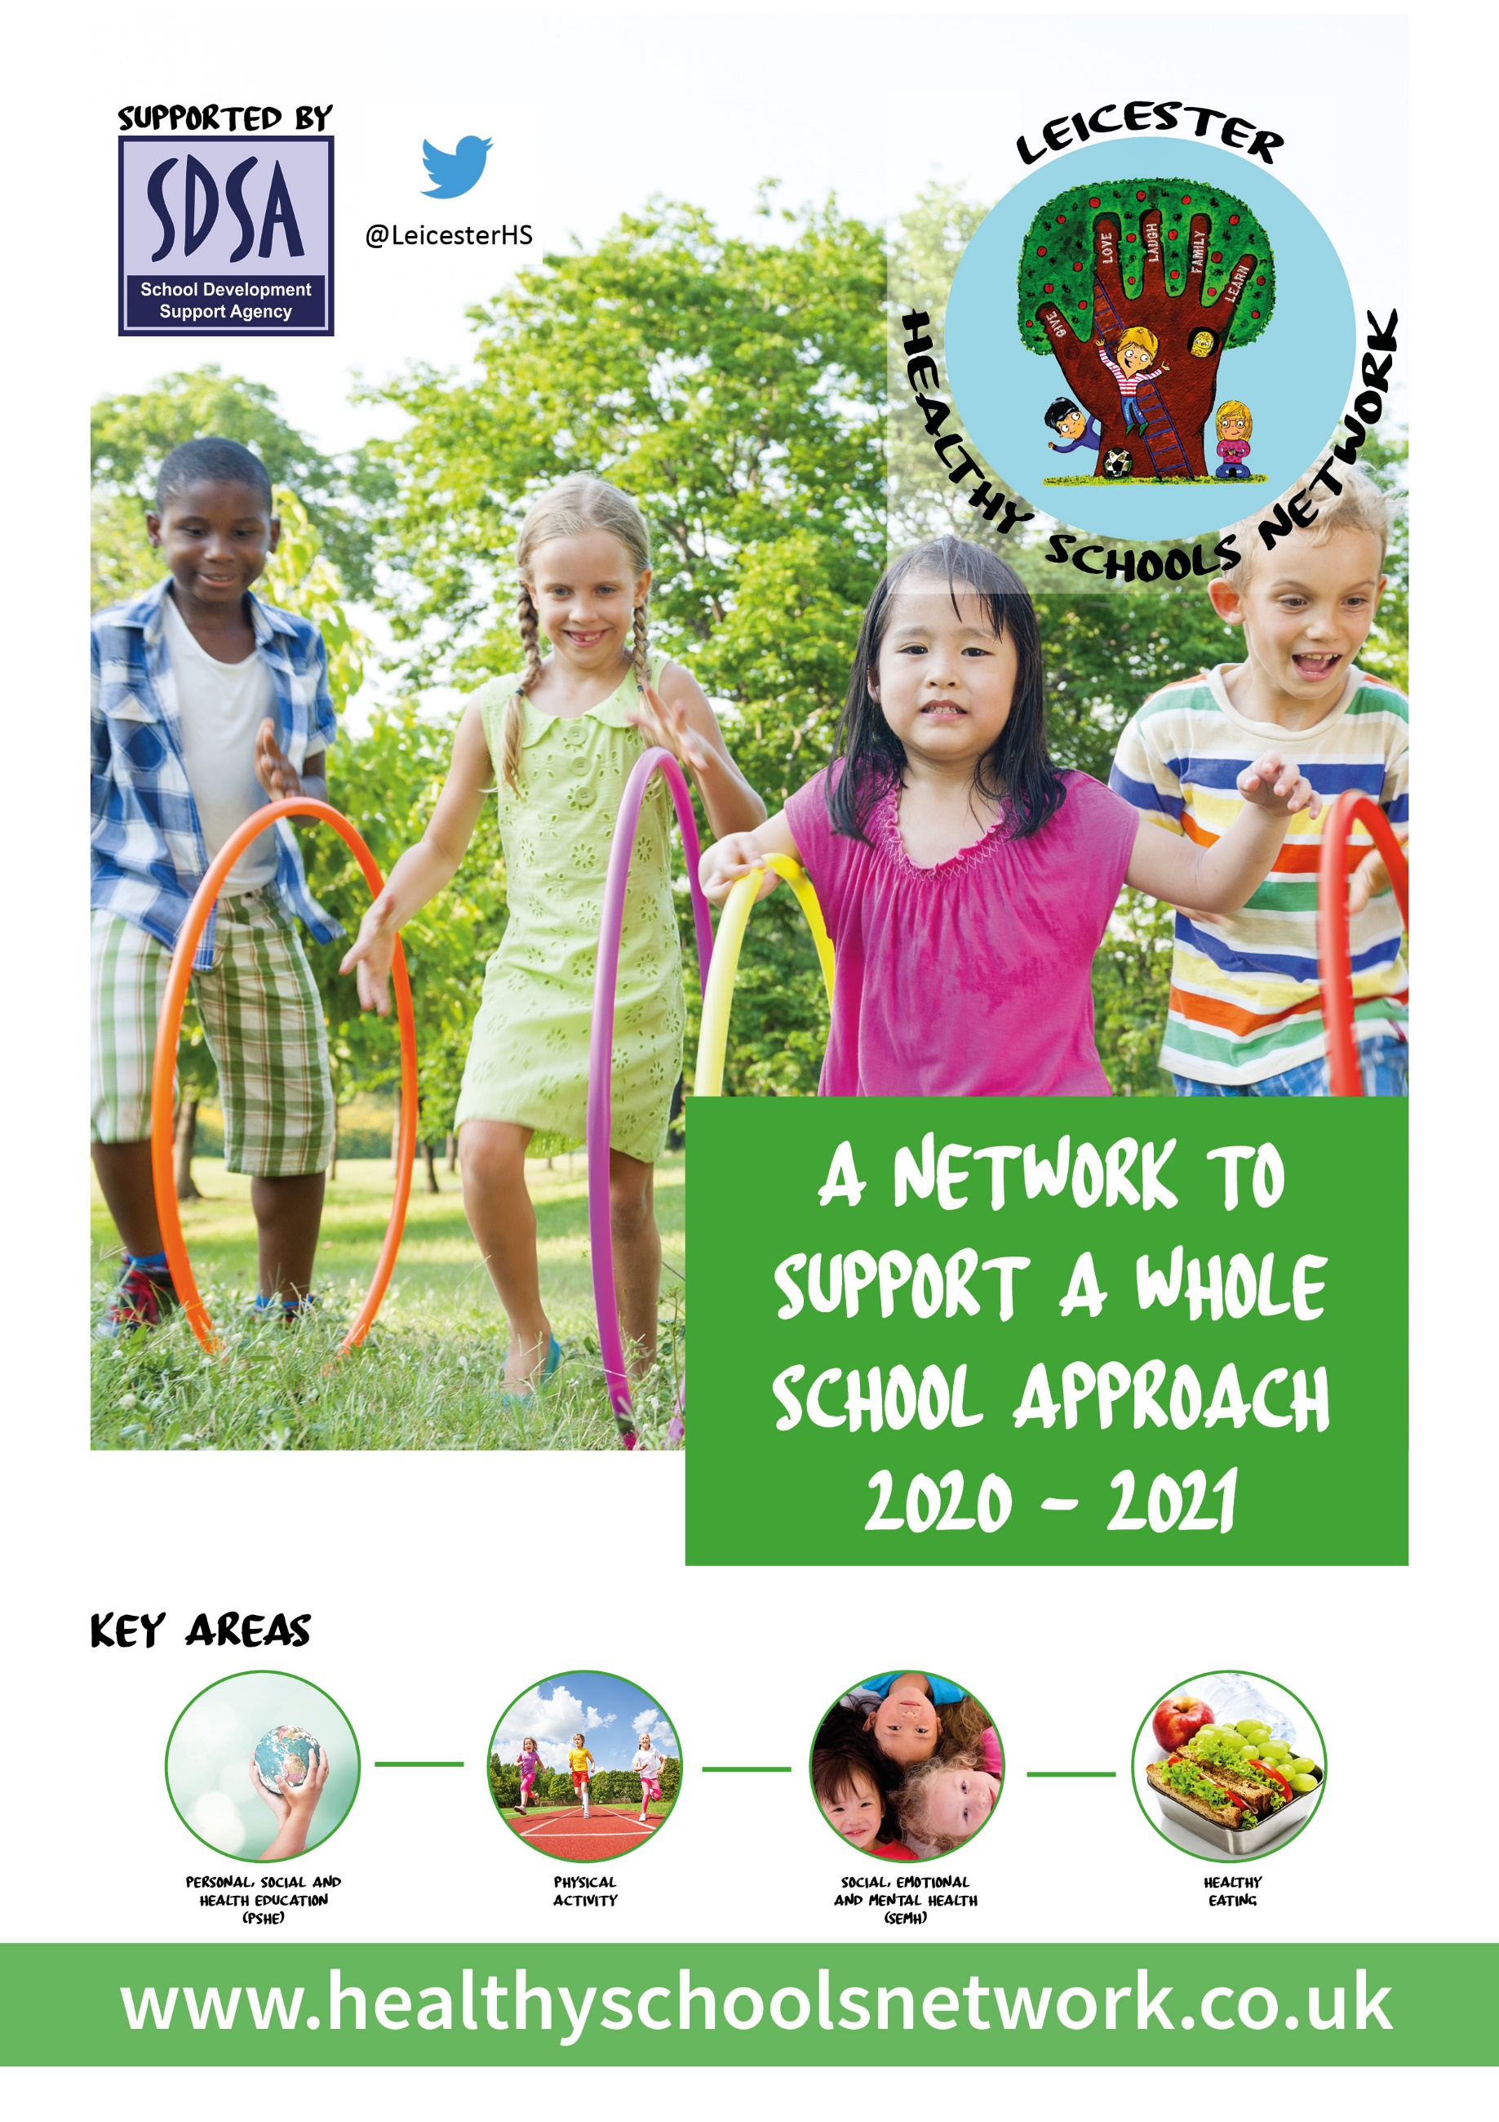
SELF-ASSESSMENT

Self-assessment Check List

The self-assessment should now be completed online by visiting https://healthyschoolsnetwork.co.uk/ and logging in using the username and password supplied to your designated Health and Wellbeing Champion. A final report should be submitted with your completed Workbook to obtain one of the Awards.

The self-assessment should be completed by the senior leadership team with representation from teachers, SENCO, pastoral staff, children and young people. As you work through the check list you will be asked to consider the extent to which you are achieving each principle and to rate progress accordingly (see table below).

Completing the self-assessment check list will be most valuable if contributors commit to honest self-refection with each other as a way to improve. This approach will also support collective understanding of the social, emotional and mental health challenges, and encourage ownership of actions needed for improvement from an early stage.

The good practice indicators will help guide the discussion in your school or college. As you complete the self-assessment check list you will need to check and challenge your rating by thinking about whether you would be prepared to stand up and defend your rating if scrutinised by other peers. The rating system is intended as a diagnostic tool to help you identify your particular strengths and areas for improvement. You may also wish to use the evidence column to record activities or interventions you feel support your rating.

Red rating
R
No evidence
You might be achieving a few of the good practice Indicators, but there are significant areas where you would want there to be more progress against the principle
Amber rating
A
Some evidence
Achieving most of the good practice indicators, but with room for improvement in some areas of the principle
Green rating
G
Strong evidence
Achieving all or nearly all of the good practice indicators for that principle

- Management and Leadership
Key Question | Indicators of good practice | Score  R A G | Evidence
How is the school or college providing visible senior leadership for emotional health and wellbeing? | Senior leadership ensure efforts to promote emotional health and mental wellbeing are accepted and embedded within the school or college.
 | A named member of the senior leadership team (SLT) has responsibility for emotional health and mental wellbeing.
 | An emotional health and mental wellbeing policy for all children and young people and staff has been developed using a whole school approach. (This should reflect national policy and guidance and include how mental health is dealt with in the school/college, how it is taught, and guidance for staff when dealing with mental health issues).
 | Governors understand emotional health and mental wellbeing issues, and support this agenda.
 | There is commitment from SLT and Governors to address social, emotional and mental wellbeing which is referenced in school or college improvement plans. Pupils, staff and parents are involved in developing policies (such as safeguarding; confidentiality; personal, social and health education (PSHE); social, moral, spiritual and cultural (SMSC) education; behaviour and rewards) so that they remain ‘live’ documents that are reviewed and responsive to the evolving needs of the school community.
There is clear understanding and knowledge of the external support services that are available to provide additional targeted mental health support (see graduated response).

The quality assurance framework for commissioning emotional health and well-being services has been implemented to ensure school /college commissioned external support services are:
• Safe and effective
• Employ qualified practitioners
• Value for money and minimise risk to the school or college

- School/College Ethos and Environment
Key Question | Indicators of good practice | Score  R A G | Evidence
How does the school or college’s culture promote respect and value diversity? | The senior leadership team provides clear leadership to create and manage the physical, social and emotional environment as these impact on staff and pupils/students emotional and mental health wellbeing.
 | There is a safe environment which nurtures and encourages young people’s sense of self-worth and self-efficacy, reduces the threat of bullying and violence and promotes positive behaviours.
 | There is a culture of inclusiveness and communication that ensures all staff and young people’s concerns can be addressed (including the concerns of those who may be at particular risk of poor mental health).
 | There is dedicated staff training, sign posting information (staff and students), PSHE and library resources and targeted mental health campaigns (including tackling stigma and discrimination).

- Curriculum, Teaching and Learning
Key Question | Indicators of good practice | Score  R A G | Evidence
What focus is given within the curriculum to social and emotional learning and promoting personal resilience, and how is learning assessed? | The curriculum promotes positive behaviours and successful relationships and helps reduce disruptive behaviour and bullying. This includes targeted programmes and interventions which:  - Ensure implementation of high-quality programmes and interventions  - Explicitly teach social and emotional skills, attitudes and values, using well-trained and enthusiastic teachers and positive, experiential and interactive methods.  - Integrate this learning into the mainstream processes of school or college life
 | Social and emotional skills development are integrated within all subject areas (these skills include problem solving, coping, conflict management / resolution and understanding and managing feelings).
 | Personal, social and health education (PSHE) and sex and relationships education (SRE) are embedded across the curriculum and culture of the organisation. The school/college’s approach seeks to build emotional skills as well as knowledge, and parents are involved.

- Student Voice
Key Question | Indicators of good practice | Score  R A G | Evidence
How does the school or college ensure all students have the opportunity to express their views and influence decisions? | The senior leadership team recognise children and young people have a powerful voice in learning, decision making, peer led approaches and development of strong social networks (regardless of age and ability).
 | There are a variety of strategies in place to ensure all children and young people are able to contribute to decisions individually or collectively that may impact on their social and emotional wellbeing (regardless of age and ability).
 | Young people and staff work in partnership to formulate, implement and evaluate organisation-wide approaches to promoting social, emotional and mental wellbeing.
 | Children and young people are actively engaged in discussions about emotional health and mental wellbeing provision in their school or college.
 | In secondary education / further education: young people involved in the creation, delivery and evaluation of staff training and continuing professional development activities in relation to social, emotional and mental wellbeing.

- Staff Development, Health and Wellbeing
Key Question | Indicators of good practice | Score  R A G | Evidence
How are staff supported in relation to their own health and wellbeing and to be able to support student wellbeing? | Use of the Government e-learning platform MindEd (www.minded.org.uk/) is promoted
 | Training is provided to staff so that they have the knowledge, understanding and skills to deliver a curriculum that effectively integrates the development of social and emotional skills within subject areas.
 | Training is provided to staff to support children and young people’s social, emotional and psychological wellbeing. This includes identifying and assessing the early signs of anxiety, emotional distress and behavioural problems (including primary school children). Staff are able to assess whether a specialist should be involved and can make an appropriate request using the graduated response.
Support is provided to enable staff to reflect on, and take actions to enhance, their own wellbeing and by promoting a work-life balance for staff.

The workplace charter provides a set of national standards for workplace health (including mental health) (www.wellbeingcharter.org.uk).
 | A system is in place for assessing and monitoring the mental wellbeing of staff as part of professional development and performance reviews. This includes using staff attitude surveys, open conversations to provide feedback and investment in training.

- Identifying Need and Monitoring Impact
Key Question | Indicators of good practice | Score  R A G | Evidence
How does the school or college assess the needs of students and the impact of interventions to improve wellbeing? | A systematic measure is used to assess pupil emotional health and mental wellbeing (including identifying those who need extra support). Assessment outcomes are used as the basis for planning activities and measuring impact.
Data is used effectively to monitor and act on changes in pupils’ patterns of attainment, attendance or behaviour.

There is an effective pastoral system so that at least one member of staff (e.g. a form tutor or class teacher) knows each pupil well and can spot where changes in behaviour may have a root cause that needs addressing.
 | Understanding of pupils’ needs is used to inform commissioning decisions at school / college level or across school clusters.
 | The impact of any support that is put in place is monitored and recorded as per the graduated response.

- Working with Parents, Carers and Community
Key Question | Indicators of good practice | Score  R A G | Evidence
How does the school or college work in partnership with parents and carers to promote emotional health and mental wellbeing? | All pupils and, where appropriate, their parents or carers (including adults with responsibility for looked after children) are engaged in genuine participation, including pupils / students whose families may feel blamed or stigmatised.
 | Parents are provided with information about the school’s policies on promoting social and emotional wellbeing and preventing mental health problems.
 | Parents, carers and other family members living in disadvantaged circumstances are given the support they need to participate fully in activities to promote social and emotional wellbeing. This should include support to participate fully in any parenting sessions, for example by offering a range of times for the sessions or providing help with transport and childcare. This might involve liaison with family support agencies.

8. Coordinated Support
Key Question | Indicators of good practice | Score  R A G | Evidence
How does the school or college ensure timely and effective identification of students who would benefit from coordinated support and ensure an appropriate graduated response is in place? | Specific help for children most at risk (or already showing signs) of social, emotional and behavioural problems.
 | Children who are showing difficulties in managing emotions or behaviour are identified and assessed, using joint problem solving through the Assess-Plan-Do-Review process with the child and their parents/carers and other professionals.
 | An action plan is agreed as the first stage of a graduated response and more intense evidence based work is provided on social and emotional skill development according to the child’s needs.
 | The need for additional external agency involvement is considered through: Assess-Plan-Do-Review cycles e.g. consultation or targeted support.
 | Young people receive clear and consistent information about the opportunities available for them to discuss personal issues and emotional concerns.
 | Availability of pastoral care and support is well known and easy to access.

ACTION PLAN TEMPLATE
(building on the results of the self-assessment)
Key Question | What are we going to do to get better in this area? Think about the things you will have to do in each of the core principles. | Who will do it? Who will do the things you have decided need to be done? | When will it be done by? When do you plan to have completed the action or is there a date you want to review your progress?
How is the school or college providing visible senior leadership for emotional health and mental wellbeing?
How does the school or college’s culture promote respect and value diversity?
What focus is given within the curriculum to social and emotional learning and promoting personal resilience, and how is learning assessed?
How does the school or college ensure timely and effective identification of students who would benefit from targeted support and ensure appropriate referral to support services?
How does the school or college ensure all students have the opportunity to express their views and influence decisions?
How are staff supported in relation to their own health and wellbeing and to be able to support student wellbeing?
How does the school or college assess the needs of students and the impact of interventions to improve wellbeing?
How does the school or college work in partnership with parents and carers to promote emotional health and mental wellbeing?

Leicester
Healthy Schools Network

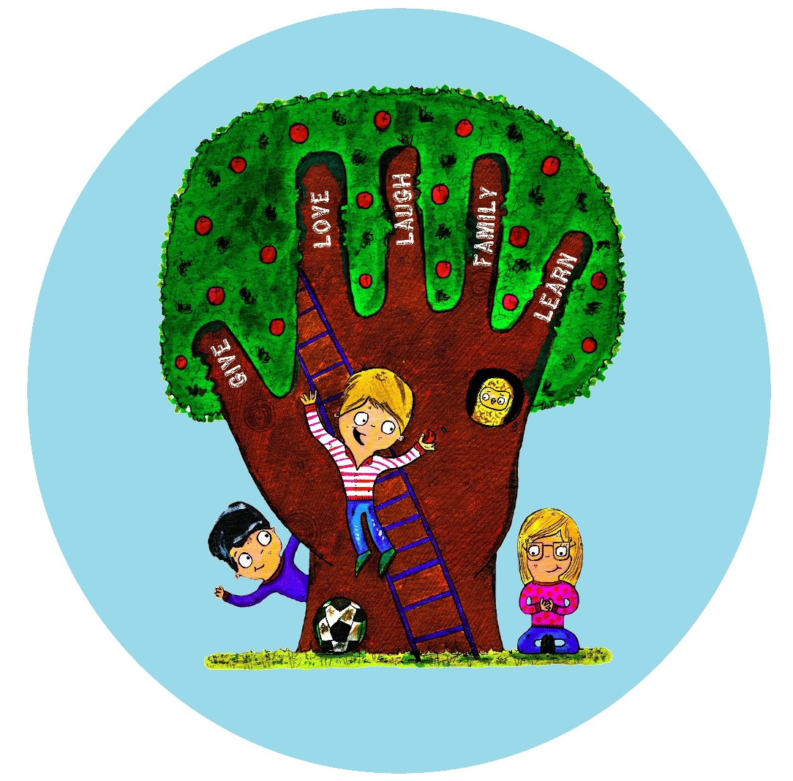
Healthy Schools Network
School Development Support Agency (SDSA)
1st Floor | Alliance House | 6 Bishop Street | Leicester | LE1 6AF
0116 299 5942 | office@sdsa.net

