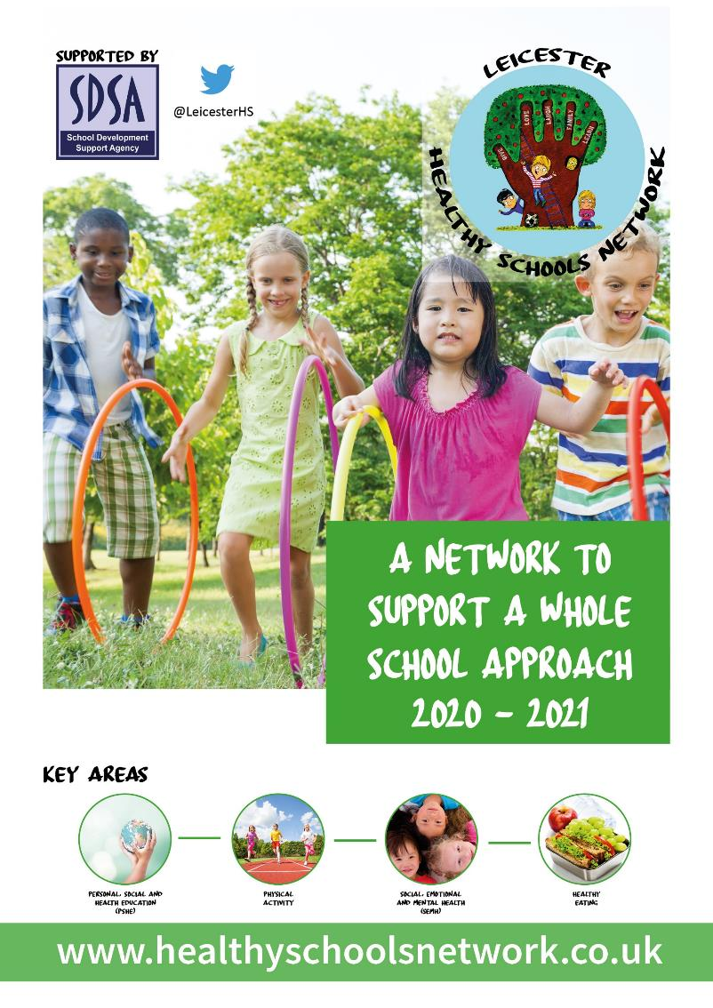
Workbook

Welcome

The Healthy Schools Network was set up as a response to demand expressed in the April 2016 survey of Leicester City schools and is supported by the School Development Support Agency (SDSA)*. The Network is a programme aimed to meet the health and wellbeing needs of children and young people, helping to raise attainment levels within schools and aims to bring together and showcase the provision available for schools by building relationships from around the East Midlands. The Network is designed to offer school-to-school support for this vital aspect of the wider curriculum and the arrangements, in Leicester, are now school-funded.

Last year the Network involved 38% of Leicester city schools, consisting of around 19,500 pupils.

The 2020-21 programme will encourage a Whole School Approach to Health and Wellbeing through:
- Designating a Health and Wellbeing Champion
- Health and Wellbeing Champions Conferences
- Networking Meetings
- Working towards an award (completing/updating workbook)
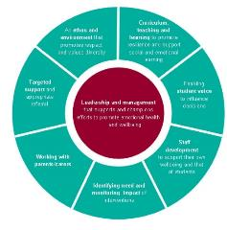
- Online resources/signposting

The Network is underpinned by the Public Health England’s (2015) ‘Eight Principles of a Whole Schools Approach’. Using the principles, we will be asking schools to create an action plan against each of the key four areas (Personal, Social and Health Education (PSHE); Physical Activity; Social, Emotional and Mental Health (SEMH) and Healthy Eating). Each of the four action plans will be combined and updated at upcoming conferences throughout the year.

Your school was asked to nominate a designated ‘Health and Wellbeing Champion’ to attend virtual conferences to enhance their skills and knowledge. These virtual conferences are designed to showcase the fantastic work already happening within Leicester schools and allows the sharing of good practice. The virtual conferences are developed to inspire the champions by having keynote speakers, developing action plans and interactive workshops.

The Healthy Schools Network also offers Network Meetings per academic year, covering the four key areas; Personal, Social and Health Education (PSHE); Social, Emotional and Mental Health (SEMH); Physical Activity; and Healthy Eating. This gives the network members a chance to share good practice and consists of briefings from professional providers; ensuring schools are aware of the support available in the relevant areas and keeping them updated with current health and wellbeing affairs.
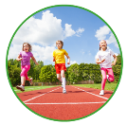

As your schools designated Health and Wellbeing Champion, your role will be the key link between the work of the Healthy Schools Network and its impact on this aspect of the wider curriculum. The role is most effective when information is shared with your school colleagues and school community.

It is widely recognised that a child’s emotional health and wellbeing influences their cognitive development and learning, as well as their physical and social health and their mental wellbeing in adulthood. Therefore, it is important that schools are supported to adopt a comprehensive, ‘Whole School’ approach to promoting the social and emotional wellbeing of children and young people.

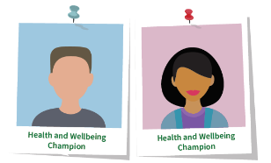
The schools’ Health and Wellbeing Champions are people who, with training and support, will help others to enjoy healthier lives by raising awareness, sharing messages, removing barriers and creating supportive networks and environments.

Your Health and Wellbeing Champion should:
- be a positive thinker
- be friendly and approachable
- be enthusiastic and motivated
- be non-judgemental
- be innovative and creative
- care about their own health and the health of others

This Workbook has been designed to allow your school to audit emotional health and wellbeing approaches in the four key areas, create an action plan for a Whole School Approach and to look at sharing good practice.

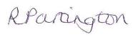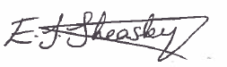

Rebecca Partington and Emma Sheasby
Healthy Schools Network Team

*The School Development Support Agency (SDSA) is a not-for-profit organisation which supports school-led improvement. The SDSA are an innovative school support organisation led by experienced education professionals and project managers. The SDSA have a proven track record of contributing to positive outcomes for children and young people.

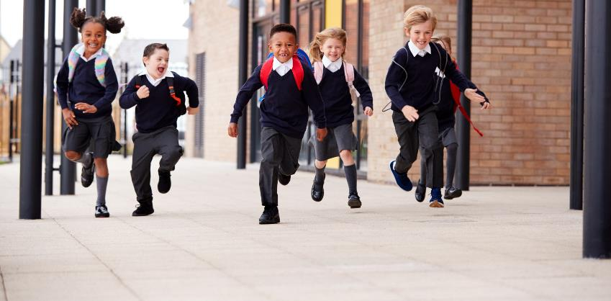
The Whole School Approach

Healthy Schools takes a whole systems approach with the aim of integrating health and wellbeing within the ethos, culture, routine life and core business of the school setting. This is known as the ‘Whole School Approach’ and involves addressing the needs of pupils, staff and the wider community, not only within the curriculum, but across the whole-school and learning environment.

The Whole School Approach encompasses these eight over-arching areas of school improvement:
- leadership, management and managing change
- learning and teaching, curriculum planning and resourcing
- school culture and environment including policy development
- giving children and young people a voice
- provision of support services for children and young people
- staff continuing professional development (CPD) needs, health and wellbeing
- partnerships with parents/carers and local communities
- assessing, recording and reporting the achievement of children and young people.

The Whole School Approach provides a model to support change and development involving children, young people, staff, parents/carers and governors.

It also provides a solid foundation from which developments and improvements are embedded in a systematic way throughout the school and effectively contribute to the physical and emotional health and wellbeing of all members of the school community.

By adopting the Whole School Approach schools ensure full engagement with the school community and secure sustainable improvements.

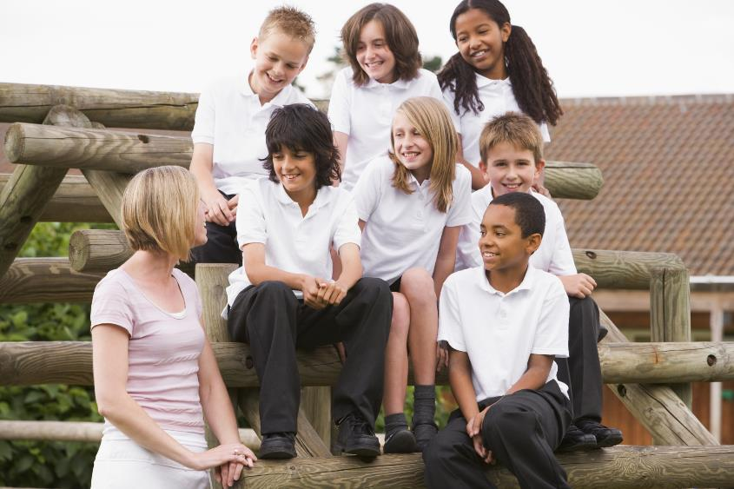
The Eight Principles of a Whole School Approach
(Promoting Children and Young People’s Emotional Health and Well-Being – a Whole School and College Approach, Public Health England and Young People’s Mental Health Coalition, March 2015)

- Leadership and management that supports and champions efforts to promote emotional health and wellbeing
- An ethos and environment that promotes respect and values diversity
- Curriculum, teaching and learning to promote resilience and support social and emotional learning
- Enabling student voice to influence decisions
- Staff development to support their own wellbeing and that od students
- Identifying need and monitoring impact of interventions
- Working with parents/carers
- Targeted support and appropriate referral

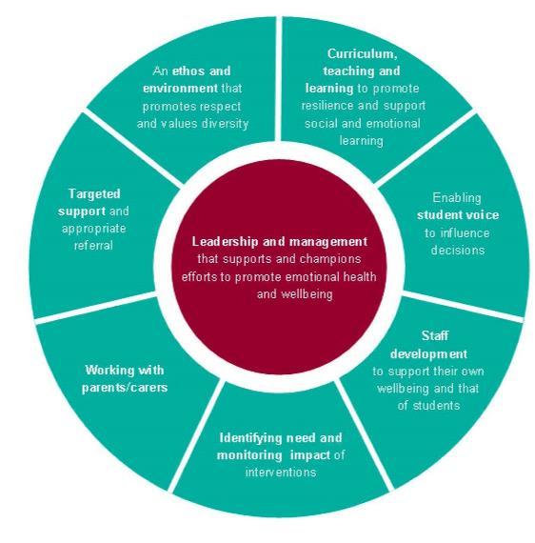
https://www.gov.uk/government/publications/promoting-children-and-young-peoples-emotional-health-and-wellbeing

About your school

School Name

Health & Wellbeing Champion Name(s)

What is your schools mission statement?

Who are the lead members of staff responsible for aspects of health and wellbeing at school?

Area | Lead Member
Personal, Social and Health Education (PSHE)
Social, Emotional and Mental Health (SEMH)
Healthy Eating
Physical Activity

Development for this academic year (2020/21)

Health & Wellbeing Champion | Pupils | Staff | Whole Community
e.g., Developing my understanding of Health & Wellbeing. | e.g., Develop resilience. | e.g., Encourage staff to deliver outstanding PSHE lessons. | e.g., Enhance the knowledge of health and wellbeing to the community

As the Health and Wellbeing Champion for your school, how confident do you feel?
With 1 representing minimal/no knowledge and 10 representing extensive knowledge

Please circle/colour in how much of an understanding you have around:
 | 1 | 2 | 3 | 4 | 5 | 6 | 7 | 8 | 9 | 10
PSHE
Physical Activity
SEMH
Healthy Eating

What are the key health and wellbeing policies at your school?
You may wish to list these and keep a note of the date each policy is next due for review.

 | Last Review  Month/Year | Next Review  Month/Year
PSHE education
Sex and relationship education (SRE)
Confidentiality Policy / Statement
Inclusion/Special Educational Needs Policy
E-Safety
Safeguarding Policy
Physical Activity (not just PE)
Anti-bullying (Emotional health & wellbeing)
First Aid & Medication
Food Policy
Behaviour & Discipline
No Smoking Policy & managing drug related incidents
Drug education policy
Travel plan
Staff Wellbeing Policy
Mental Health and Emotional Wellbeing Policy

What Awards have your school achieved or working towards?
We are aware that schools participate in a number of awards – we have provided a few but are aware there are lots of others. Please record all that you have achieved or are working towards.

 | Working towards Award | Award Obtained | Valid from - until
Eco-Schools Green Flag (Bronze/Silver) International
Food for Life (Bronze/Silver/Gold)
National
Positive and Peaceful Places
Local
Healthier Air for Leicester Schools
Local
The Green Tree Schools Award
National (Woodland Trust)
Mental Health in Schools (Bronze/Silver/Gold)
National
SMSC Quality Mark
National
Jigsaw Flagship School Status
National
Wellbeing Award for Schools
National
Healthy Schools Rating Scheme
National

What other activities are you part of?

Activity | Local / National /International | Our School is involved  (please tick)
Sustrans
Living Streets Walk to School | National with Local offers
Everyone’s Welcome | Local

Is your school a member of any of the following associations?

Organisation | Membership  Yes/No
PSHE Association
Sex Education Forum

Self-assessment (Online)

The self-assessment should now be completed online by visiting https://healthyschoolsnetwork.co.uk/ and logging in using the username and password supplied to your designated Health and Wellbeing Champion. A final report should be submitted with your completed Workbook to obtain one of the Awards.

There are 8 sections to complete:

- Management and Leadership
- School/College Ethos and Environment
- Curriculum, Teaching and Learning
- Student Voice
- Staff Development, Health and Wellbeing
- Identifying Need and Monitoring Impact
- Working with Parents, Carers and Community
- Coordinated Support

The self-assessment should be completed by the senior leadership team with representation from teachers, SENCO, pastoral staff, children and young people. As you work through the check list you will be asked to consider the extent to which you are achieving each principle and to rate progress accordingly (see table below).

Completing the self-assessment check list will be most valuable if contributors commit to honest self-refection with each other as a way to improve. This approach will also support collective understanding of the social, emotional and mental health challenges, and encourage ownership of actions needed for improvement from an early stage.

The good practice indicators will help guide the discussion in your school or college. As you complete the self-assessment check list you will need to check and challenge your rating by thinking about whether you would be prepared to stand up and defend your rating if scrutinised by other peers. The rating system is intended as a diagnostic tool to help you identify your particular strengths and areas for improvement. You may also wish to use the evidence column to record activities or interventions you feel support your rating.

Red rating
R
No evidence
You might be achieving a few of the good practice Indicators, but there are significant areas where you would want there to be more progress against the principle
Amber rating
A
Some evidence
Achieving most of the good practice indicators, but with room for improvement in some areas of the principle
Green rating
G
Strong evidence
Achieving all or nearly all of the good practice indicators for that principle

Personal, Social and Health Education (PSHE)

About PSHE
Personal, Social and Health Education (PSHE) is a non-statutory subject, on the school curriculum, through which pupils develop the knowledge, skills and attributes they need to manage many of the critical opportunities, challenges and responsibilities they will face as they grow up and in adulthood.

Although PSHE is a non-statutory subject, the national curriculum states that all state schools ‘should make provision for personal, social, health education (PSHE), drawing on good practice'. Maintained schools are required to publish details of the curriculum by year group for all subjects, including PSHE. This should be with the same level of detail as for all other subjects. Academies, free schools and independent schools are not bound by the national curriculum, however all schools share the statutory duties. A school’s best approach is therefore to ensure that a comprehensive programme of PSHE is in place.

By teaching pupils to stay safe and be healthy, and by building self-esteem, resilience and empathy, an effective PSHE programme can tackle barriers to learning, raise aspirations, and improve the life chances of the most vulnerable and disadvantaged pupils. Evidence shows that well-delivered PSHE can address teenage pregnancy, substance misuse, unhealthy eating, lack of physical activity, and emotional health.

In July 2018, the government announced that all schools will have to teach Relationships and Sex Education (secondary)/Relationships Education (primary) and health education. The relationships and health aspects of PSHE education became compulsory in all schools from 2020.

Included in what will be delivered:
- features of healthy friendships, family relationships and other relationships
- how relationships can affect physical and mental health
- staying safe online
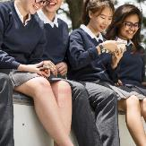
- how to use technology safely, responsibly and respectfully
- how to keep personal information private
- healthy eating
- keeping fit
- prevention of health problems
- recognition of mental health and ways to support good mental health
- consent
- development of qualities such as confidence, resilience, self-respect
- wider social and economic issues

PSHE covers a range of topics including:

- Statutory RSE and PSHE
- Drug Education
- Personal Safety Education
- Relationships and sex education
- Social norms
- Financial education
- Physical activity
- Diet for a healthy lifestyle

On the next few pages you will find the following tools to investigate gaps and good practice that your school carries out as a Whole School approach.
- School Audit
- Action Plan
- Sharing Good Practice Template

Personal, Social and Health Education (PSHE) School Audit

Think about what PSHE activities your school currently covers, what it has covered in the past and what you would like to try in the future.
Remember there will be cross over between the four key areas.

What have you done in the past 12 months? | What do you currently do? | What would you like to try?
Organisations/Providers your school worked with | Organisations/Providers your school is working with | Organisations/Providers your school wishes to work with
Barriers and Obstacles | Barriers and Obstacles | Barriers and Obstacles

Personal, Social and Health Education (PSHE) Action Plan

Whole School Approach Area | Change/improvement to see | Date to achieve this by | Key decision maker and how to influence | Other key people and how to influence | Barriers and Obstacles
Leadership and management
Ethos and environment
Curriculum, teaching and learning
Student voice

Whole School Approach Area | Change/improvement to see | Date to achieve this by | Key decision maker and how to influence | Other key people and how to influence | Barriers and Obstacles
Staff development
Identifying need and monitoring impact
Working with parents/carers
Targeted support

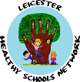
School Logo can be added here
PROJECT TITLE
EXAMPLE Primary School
Health and Wellbeing Champion NAME
PROJECT AIM:

WHAT YOU DO
and
WHAT WAS INVOLVED
and
HOW YOU DID IT

IMPACT

IMAGE
NEXT STEPS
Social, Emotional and Mental Health (SEMH)

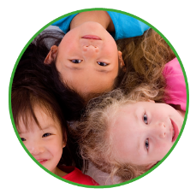
About SEMH
A focus on Emotional Health and Wellbeing is critical to the social development and educational achievement of children and young people. To reflect this, schools have had a duty to promote health and wellbeing since 2007.

Children and young people need to be able to bounce back when life gets tough. It is important for them to be able to manage their emotions and behaviour in an appropriate way.

What are the characteristics of a child- friendly school?
- reflects and realises the rights of every child;
- sees and understands the whole child in a broad context;
- is child-centred;
- is gender sensitive;
- promotes quality learning outcomes;
- provides education based on the reality of children's lives;
- is flexible and responds to diversity;
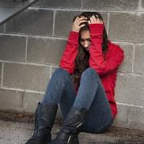
- acts to ensure inclusion, respect and equality of opportunity for all children;
- promotes mental and physical health;
- enhances teacher capacity, morale, commitment and status;
- is family focused;
- is community based.

SEMH covers a range of topics including:
- Social and emotional functioning
- Wellbeing
- The ability to regulate self and behaviour
- Mental Health difficulties
- Anti-bullying practice
- Healthy Mind Healthy Life
- Self-harm
- Supporting young carers
- Reading Well
- Staff wellbeing
- Young listeners

On the next few pages you will find the following tools to investigate gaps and good practice that your school carries out as a Whole School approach.
- School Audit
- Action Plan
- Sharing Good Practice Template

Social, Emotional and Mental Health (SEMH) School Audit

Think about what SEMH activities your school currently covers, what it has covered in the past and what you would like to try in the future.
Remember there will be cross over between the four key areas.

What have you done in the past 12 months? | What do you currently do? | What would you like to try?
Organisations/Providers your school worked with | Organisations/Providers your school is working with | Organisations/Providers your school wishes to work with
Barriers and Obstacles | Barriers and Obstacles | Barriers and Obstacles
Social, Emotional and Mental Health (SEMH) Action Plan

Whole School Approach Area | Change/improvement to see | Date to achieve this by | Key decision maker and how to influence | Other key people and how to influence | Barriers and Obstacles
Leadership and management
Ethos and environment
Curriculum, teaching and learning
Student voice

Whole School Approach Area | Change/improvement to see | Date to achieve this by | Key decision maker and how to influence | Other key people and how to influence | Barriers and Obstacles
Staff development
Identifying need and monitoring impact
Working with parents/carers
Targeted support

School Logo can be added here
PROJECT TITLE
EXAMPLE Primary School
Health and Wellbeing Champion NAME
PROJECT AIM:

WHAT YOU DO
and
WHAT WAS INVOLVED
and
HOW YOU DID IT

IMPACT

IMAGE
NEXT STEPS
Healthy Eating
About Healthy Eating
Good eating habits are developed during childhood. If encouraged to enjoy healthier food and drink early on, it is more likely that these positive behaviours will remain with children and young people throughout life.

Children and young people spend, on average, a quarter of their waking lives in schools, so schools can have a positive influence over their knowledge, experience and behaviour. The knowledge developed in the classroom about a healthier diet, the food that is offered and promoted throughout the school day, as well as the attitude of the whole school community, can have a major influence on children and young people. The lifelong learning skills they need to make appropriate food choices and to develop a positive attitude towards diet and health can all be influenced at school.

It is important that messages about healthy eating and healthy lifestyles are consistent. Schools can help provide these and, by involving the whole school community, they can help encourage healthier behaviour outside of the school environment as well.

Schools that have completed the Food for Life Award will already have useful evidence that they contribute to network meetings to help others.

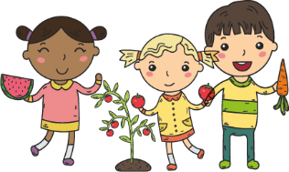
Healthy Eating covers a range of topics including:
- The National Child Measurement Programme
- Healthy Pupil Capital fund
- Healthy Eating
- Healthy Me

On the next few pages you will find the following tools to investigate gaps and good practice that your school carries out as a Whole School approach.
- School Audit
- Action Plan
- Sharing Good Practice Template

Healthy Eating School Audit

Think about what Healthy Eating activities your school currently covers, what it has covered in the past and what you would like to try in the future. Remember there will be cross over between the four key areas.

What have you done in the past 12 months? | What do you currently do? | What would you like to try?
Organisations/Providers your school worked with | Organisations/Providers your school is working with | Organisations/Providers your school wishes to work with
Barriers and Obstacles | Barriers and Obstacles | Barriers and Obstacles
Healthy Eating Action Plan

Whole School Approach Area | Change/improvement to see | Date to achieve this by | Key decision maker and how to influence | Other key people and how to influence | Barriers and Obstacles
Leadership and management
Ethos and environment
Curriculum, teaching and learning
Student voice

Whole School Approach Area | Change/improvement to see | Date to achieve this by | Key decision maker and how to influence | Other key people and how to influence | Barriers and Obstacles
Staff development
Identifying need and monitoring impact
Working with parents/carers
Targeted support

School Logo can be added here
PROJECT TITLE
EXAMPLE Primary School
Health and Wellbeing Champion NAME
PROJECT AIM:

WHAT YOU DO
and
WHAT WAS INVOLVED
and
HOW YOU DID IT

IMPACT

IMAGE
NEXT STEPS
Physical Activity
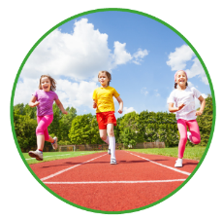
About Physical Activity
Physical Activity is an integral part of daily life in a health-promoting school and can contribute to the physical, social and emotional wellbeing of all children, young people and staff within the school community.

Engaging in regular Physical Activity and eating well are extremely important in helping to maintain a healthy body weight.

Schools can use the Healthy School criteria to provide evidence that there is a sustainable whole-school approach to Physical Activity.

Any type of Physical Activity is beneficial, and just encouraging children and young people to reduce the amount of time they spend sitting or being inactive is a good starting point.

Children and young people aged 5-18 should engage in moderate to vigorous intensity physical activity for at least 60 minutes and up to several hours a day.
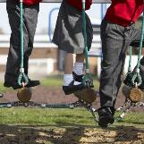
The greatest benefits come from engaging in a broad range of Physical Activity including:
- PE lessons
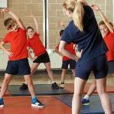
- sports
- dance
- outdoor activities
- exercise and training sessions
- walking/jogging
- cycling
- skateboarding
- active play
- roller blading
- The Daily Mile
- Road Safety Education

On the next few pages you will find the following tools to investigate gaps and good practice that your school carries out as a Whole School approach.
- School Audit
- Action Plan
- Sharing Good Practice Template
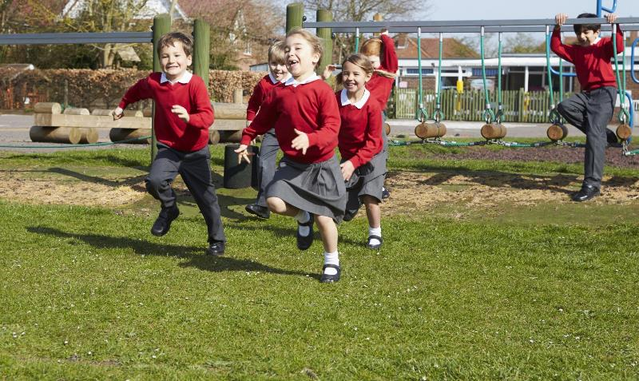

Physical Activity School Audit

Think about what Physical Activity activities your school currently covers, what it has covered in the past and what you would like to try in the future.
Remember there will be cross over between the four key areas.

What have you done in the past 12 months? | What do you currently do? | What would you like to try?
Organisations/Providers your school worked with | Organisations/Providers your school is working with | Organisations/Providers your school wishes to work with
Barriers and Obstacles | Barriers and Obstacles | Barriers and Obstacles
Physical Activity Action Plan

Whole School Approach Area | Change/improvement to see | Date to achieve this by | Key decision maker and how to influence | Other key people and how to influence | Barriers and Obstacles
Leadership and management
Ethos and environment
Curriculum, teaching and learning
Student voice

Whole School Approach Area | Change/improvement to see | Date to achieve this by | Key decision maker and how to influence | Other key people and how to influence | Barriers and Obstacles
Staff development
Identifying need and monitoring impact
Working with parents/carers
Targeted support

School Logo can be added here
PROJECT TITLE
EXAMPLE Primary School
Health and Wellbeing Champion NAME
PROJECT AIM:

WHAT YOU DO
and
WHAT WAS INVOLVED
and
HOW YOU DID IT

IMPACT

IMAGE
NEXT STEPS
Whole School Approach to a Healthy School

Now that you have looked at the four key areas and identified change and improvement needed are there any overlapping themes that could be addressed as a whole school? Are there any barriers and obstacles that need to be addressed? Do you know what to do in order to overcome the barriers and obstacles? Complete this action plan using all four key areas.

Whole School Approach Area | Change/improvement to see | Date to achieve this by | Key decision maker and how to influence | Other key people and how to influence | Barriers and Obstacles
Leadership and management
Ethos and environment
Curriculum, teaching and learning
Student voice

Whole School Approach Area | Change/improvement to see | Date to achieve this by | Key decision maker and how to influence | Other key people and how to influence | Barriers and Obstacles
Staff development
Identifying need and monitoring impact
Working with parents/carers
Targeted support

SILVER AWARD
The project evidence must be a minimum of 1,000 words
Title of your school based project

Description of your school-based project (minimum of 1,000 words)
(please include what you did, what was involved, who was involved, how you did it, next steps of how it is sustainable for 2 years)

Image can be added here
Brief description of your school-based project

WHAT YOU DID
and
WHAT WAS INVOLVED
and
WHO WAS INVOLVED
and
HOW YOU DID IT
Our school-based project focussed on these areas of the Whole School Approach:
- Curriculum, teaching and learning
- Ethos and environment
- Identifying need and monitoring impact
- Leadership and Management
- Staff Development
- Student voice
- Targeted support
- Working with parents/carers
School Logo can be added here

TITLE OF YOUR SCHOOL BASED PROJECT
EXAMPLE School
NEXT STEPS (how will this project be sustained for 2 years)
Our school based project fits under the following key area(s):
- PSHE
- SEMH
- Healthy Eating
- Physical Activity
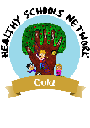
Gold AWARD
The project evidence must be a minimum of 1,000 words
Name of Schools you Supported

Description of how you supported each other (minimum of 1,000 words)
(please include what you did, what was involved, who was involved, how you did it, next steps of how it is sustainable for 2 years)

Image can be added here
Brief description of how you supported each other

WHAT YOU DID
and
WHAT WAS INVOLVED
and
WHO WAS INVOLVED
and
HOW YOU DID IT
Our school-based project focussed on these areas of the Whole School Approach:
- Curriculum, teaching and learning
- Ethos and environment
- Identifying need and monitoring impact
- Leadership and Management
- Staff Development
- Student voice
- Targeted support
- Working with parents/carers
School Logo can be added here

EXAMPLE School &
EXAMPLE School
NEXT STEPS (how will this project be sustained for 2 years)
Image can be added here

Leicester
Healthy Schools Network

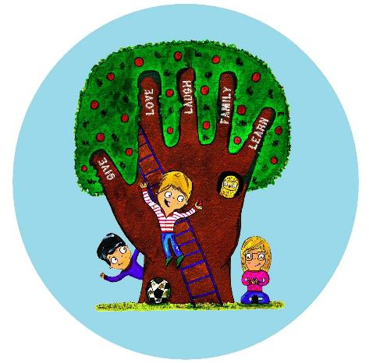
Healthy Schools Network
School Development Support Agency (SDSA)
1st Floor | Alliance House | 6 Bishop Street | Leicester | LE1 6AF
0116 299 5942 | office@sdsa.net

